**What’s on, Shetland **

**October 2024**

Our Community Groups are there to be enjoyed by anyone living with dementia or experiencing difficulties with their memory, including their families and friends. All are welcome; people who can attend independently and/or, for those unable to do so should come with a companion who can provide any support for them.

We are unable to transport for these groups and therefore it is your responsibility to get to and from this community activity, safely. Please speak to us, so we can support you to explore other transport options.

We are also here for you with a warm drink, food and company, please see below for more details. If you are unsure, or have questions about any of the groups, or have an idea for a new group, please let us know. Contact:

**Dementia Advisor:** Alanda Anderson 01595 720344/07760177049/ aanderson@alzscot.org

**Community Activities Organiser:** Linda Hughson 01595720343/07795256424/ [lhughson@alzscot.org](mailto:lhughson@alzscot.org)

|  |  |  |  |
| --- | --- | --- | --- |
|  | | | |
| **In Person Group** |  |  |  |
| **Wednesday’s**  **9th - Whaling**    **23rd - WWII** | **Museum socials**  Shetland Museum visit, explore heritage themes with tea/coffee. Hays Dock, Lerwick |  | 14.00 – 15.30 |
| **Wednesday’s,**  **2nd & 30th** | **DRC Drop-in**  DRC, 66 Burgh Road, Lerwick |  | 14.00 – 15.00 |
| **Wednesday 16th**  **New group** | **Friendly get together**  with a cuppa and chat  **Whiteness & Weisdale Hall** |  | 14.00 – 16.00 |
| **Thursday’s -**  **3rd ,10th ,17th**  **24th & 31st** | **Grief group** Come have a cuppa and an informal chat,  ----------------------------------------------------------------------  **TLC talks – Carers group**  DRC, 66 Burgh Road, Lk. |  | **11**.**45** – **13**.**00**  -------------------  **13**.**00** – **14**.**30** |
| **Thursday’s – 3rd10th, 17th, 24th,**  **31st** | **DRC Drop-in**  DRC, 66 Burgh Road, Lerwick |  | 14.30 – 15.30 |
| **Friday’s -**    **4th -**  **18th & 25th -** | **Shanty Sing Along, good fun and chat with Soup, a**  **cuppa & fancies**  **Sandveien Neighbourhood centre**    **Staney Hill Hall, Ladies Drive, Lerwick.** |  | 13.30 – 15.30 |



|  |  |  |
| --- | --- | --- |
| **Dementia Inclusive Activities and Events in Shetland** | |  |
| **34Living Well Hub** | Do you have a question about services in Shetland and how you can access them? Drop in for a cuppa and a chat with Rita and Theresa at:  **Scalloway** **Youth Centre on a Wednesday morning from 9.00 – 13.00,**  **Speldiburn Café, Bressay** **School** **on a Wednesday afternoon** **from 14.00 – 16.00**  **Brae Youth Centre on a Monday morning from 10.00 -14.00**  **or on a Friday from 10.00 – 16.00**  **Call 01595 744120**  livingwellhub@shetland.gov.uk |  |
| **The Well** | Worship Experience for Later Life  Held the first Wednesday of each month at  Lerwick Methodist Church, Hillhead, Lerwick | 14.00 - 15.00 |
| **Cuppa at Quoys** | Enjoy some cake and a cuppa every Tuesday morning at  Lerwick Baptist Church, Quoys, Lerwick | 10.00 - 12.00 |
| **Paths for All**  **Health Walks** | Dementia Friendly Walk Leaders organise weekly walks in  different locations across Shetland  For more information about your local group contact  Krissi Sandison: 01595 807494 / 07824477225 |  |
| **Shetland Befriending**  **Tea & Cake 18th** | Social get together, come chat and make new friends,  Islesburgh community centre  King Harald street, Lerwick | 14.30 – 16.00 |
| **Yarners Group** | Thursday afternoon reminiscence sessions (Cuppa & Chat)  Hoswick Visitor Centre, Sandwick  * Please check details with the centre on 01950 431406 before you set off. | 14.30 - 16.00 |

**For further information about any of our groups please contact us:**

**Dementia Advisor:** Alanda Anderson 01595 720344/07760177049 [/aanderson@alzscot.org](mailto:/aanderson@alzscot.org)

**Community Activity Organiser:** Linda Hughson 01595 720343/07795256424/lhughson@alzscot.org

**Commissioned Service Lead:** Catriona MacRitchie 07824561305 cmacritchie@alzscot.org 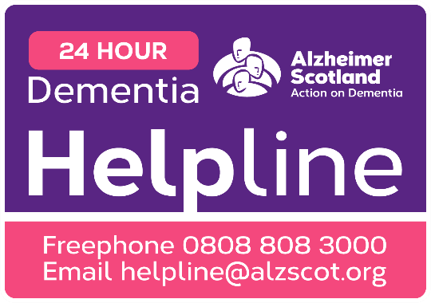

Our support and activities are only possible thanks to the donations we gratefully receive. There are many ways to support our groups, please speak to any member of staff detailed above for more details. To make a donation, please consider donating to our local Just Giving page https://www.justgiving.com/fundraising/

|  |
| --- |
| The National Dementia Advisor provides a responsive, high- quality information, advice and advocacy service  relating to all aspects of brain health and dementia. Our National Dementia Advisor service complements our  existing National Support Services such as 24 -hour Freephone  Our National Dementia Advisor  Dementia Helpline and our National Counselling Service. **Lines open: Monday – Friday, 9am – 5pm**  **To speak to one of our Dementia advisors: Call us on: 0300 373 5774 (Charged at a local call rate)**  **Email us at: NDAS@alzscot.org** |