What’s on, Shetland 

September 2024

Our Community Groups are there to be enjoyed by anyone living with dementia or experiencing difficulties with their memory, including their families and friends. All are welcome; people who can attend independently and/or, for those unable to do so should come with a companion who can provide any support for them.
We are unable to transport for these groups and therefore it is your responsibility to get to and from this community activity, safely. Please speak to us, so we can support you to explore other transport options.
We are also here for you with a warm drink, food and company, please see below for more details. If you are unsure, or have questions about any of the groups, or have an idea for a new group, please let us know. Contact:
Dementia Advisor: Alanda Anderson 01595 720344/07760177049/ aanderson@alzscot.org
Community Activities Organiser: Linda Hughson 01595720343/07795256424/ lhughson@alzscot.org
The National Dementia Advisor Service provides a responsive, high-quality information, advice and
advocacy service relating to all aspects of brain health and dementia. Our National Dementia Advisor
Service complements our existing National Support Services such as our 24-hour Freephone
Dementia
Helpline and our National Counselling Service.
Lines open: Monday – Friday, 9am – 5pm
To speak to one of our Dementia advisors: Call us on: 0300 373 5774 (Charged at a local call rate)
Email us at: NDAS@alzscot.org
In Person Group
Wednesday’s  11th | Museum socials  Shetland Museum visit, explore heritage themes (Crofting) with tea/coffee. Hays Dock, Lerwick |  | 14.00 – 15.30
Wednesday’s, 4th  & 18th | DRC Drop-in  DRC, 66 Burgh Road, Lerwick |  | 14.00 – 15.00
Wednesday  25th  (New Group) | Strom Park Social  Friendly get together with a cuppa and fancies  Strom Park club house, Weisdale |  | 14.00 – 16.00
Thursday’s -  5th , 12th , 19^{th,} &  26th | Grief group Come have a cuppa and an informal chat,  -----------------------------------------------------------------------  TLC talks – Carers group  DRC, 66 Burgh Road, Lk. |  | 11.45 – 13.00  -------------------  13.00 – 14.30
Thursday’s -  5th , 12th , 19th & 26th | DRC Drop-in  DRC, 66 Burgh Road, Lerwick |  | 14.30 – 15.30
Friday’s - 6th , 13th , 20th &  27th | Shanty Sing Along, good fun and chat with Soup, a cuppa & fancies  Staney Hill Hall, Ladies Drive, Lerwick |  | 13.30 – 15.30
Online
Can’t make it to a group in person?
Why not check out Alzheimer Scotland Virtual Resource Centre (VRC) which is an online space where you can access online groups, activities, and information sessions all from the comfort of your own home.
Find out more and see the latest Virtual Resource Centre What’s on Guide at
www.alzscot.org/virtual-resource-centre-0
Dementia Inclusive Activities and Events in Shetland
34Living Well Hub  Life after Loss  13th & 27th | Do you have a question about services in Shetland and how you can access them? Drop in for a cuppa and a chat with Rita and Theresa at:  Scalloway Youth Centre on a Wednesday morning from 9.00 – 13.00,  Speldiburn Café, Bressay School on a Wednesday afternoon from 14.00 – 16.00  Brae Youth Centre on a Monday morning from 10.00 -14.00  or on a Friday from 10.00 – 16.00  Call 01595 744120  livingwellhub@shetland.gov.uk  An informal support group drop in from 15.00 – 16.00  Brae Youth Centre
The Well | Worship Experience for Later Life  Held the first Wednesday of each month at  Lerwick Methodist Church, Hillhead, Lerwick | 14.00 - 15.00
Cuppa at Quoys | Enjoy some cake and a cuppa every Tuesday morning at  Lerwick Baptist Church, Quoys, Lerwick | 10.00 - 12.00
Paths for All  Health Walks | Dementia Friendly Walk Leaders organise weekly walks in  different locations across Shetland  For more information about your local group contact  Krissi Sandison: 01595 807494 / 07824477225
Shetland Befriending  Tea & Cake - 20th | Social get together, come chat and make new friends,  Islesburgh community centre  King Harald street, Lerwick | 14.30 – 16.00
Yarners Group | Thursday afternoon reminiscence sessions (Cuppa & Chat)  Hoswick Visitor Centre, Sandwick  * Please check details with the centre on 01950 431406 before you set off. | 14.30 - 16.00
For further information about any of our groups please contact us:
Dementia Advisor: Alanda Anderson 01595 720344/07760177049 /aanderson@alzscot.org
Community Activity Organiser: Linda Hughson 01595 720343/07795256424/lhughson@alzscot.org
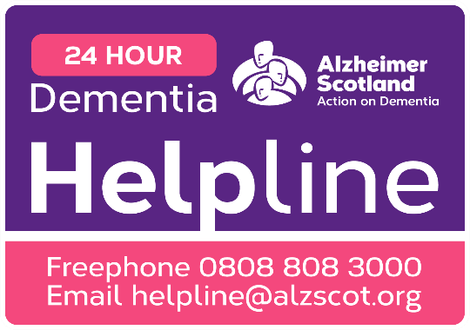
Commissioned Service Lead: Catriona MacRitchie 07824561305 cmacritchie@alzscot.org
Our support and activities are only possible thanks to the donations we gratefully receive. There are many ways to support our groups, please speak to any member of staff detailed above for more details. To make a donation, please consider donating to our local Just Giving page https://www.justgiving.com/fundraising/

