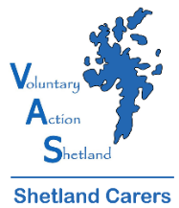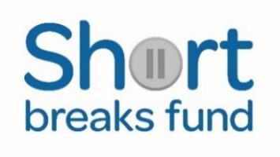
2021/22 MASSAGE SESSIONS CRITERIA
- The applicant is currently in an unpaid caring role (carer can be receiving carers allowance) and is age 18 years or above.
- The applicant feels that their caring role is having an impact on their own health and wellbeing.
- The carer and Shetland Carers Support Worker believe that accessing the Massage Sessions will benefit the carer’s physical health and emotional wellbeing.
- The applicant will be offered an initial block of six sessions. Depending on funding available, additional sessions could possibly be offered.
- There is no closing date for applications, sessions will be available while funding allows.
- Applicants will not be eligible for massage sessions if they have received a Short Break grant within the current grant period, or an overnight Respitality Break.
- Eligible applicants will also be asked to complete a health and wellbeing survey to support their application.
Notes about application process
Once Shetland Carers has received your application, you will be contacted by a staff member and, if you meet our eligibility criteria, a referral will be made. You will then be asked to contact Babs Clubb, and her contact details will be given for you to book your sessions. Carers will be offered six sessions in total, completely free. Sessions will be at The Mission – Creativity & Wellness Centre, 2 Harbour Street, Lerwick (former Hjaltland Housing Association building & former Fisherman’s Mission). Carers can choose from a 55 minute back massage or a 30 minute express back massage. Babs may also be able to offer other types of session if required.
Please note that most bookings are taken online or through Babs’ Facebook or Instagram pages. However, if a carer is unable to access online booking, then an email or text can be sent to Babs instead. Contact details will be given.
At the time of booking, card details will be asked for to confirm the booking. When a carer’s block of sessions are complete, no payment will be taken and instead Shetland Carers will be invoiced.
Cancellation Policy – if a carer doesn’t show or cancels within 24 hours, Shetland Carers will be fully charged for the session. We would ask carers, as far as possible, to give Babs more than 24 hours notice if sessions need to be cancelled or changed. Appointments can be rescheduled for free via your confirmation email or by messaging Babs directly.
You can apply for the Massage Sessions online at https://www.shetlandcarers.org/support/massage-sessions-for-carers or email carers@shetland.org or call Amanda Brown at Shetland Carers to obtain a paper version of the application form on 01595 743923.
After Your Massage Sessions
As part of the conditions for the massage sessions, you will be asked to complete an evaluation form telling us how you found the application, referral and booking process and if the sessions have been helpful for you. As well as enabling us to report back to our funder, this information helps us to monitor the success and take-up of the service and make improvements where necessary.
Website: https://www.babsclubstudio.com Facebook: https://www.facebook.com/babsclubstudio

