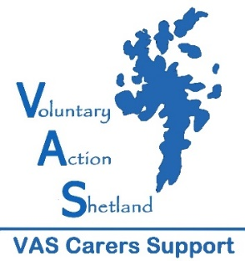
2018/19 CRITERIA FOR SHORT BREAKS GRANTS
- The applicant is currently caring for someone who is 21 years or older.
- The applicant is doing a significant amount of caring.
- Applicant can only receive one grant per year and if more than one carer in the family one per household.
- Details of the intended break to be provide along with a costing.
- Applicant has not received a short break grant from another source eg Alzheimer’s Scotland
- Other forms of support have been taken into account eg SCAS, local authority respite, care at home

Priority will be given to:-
- Carers who do not have other family members to support them
- Carers who are experiencing social isolation
- Carers who have health and well being problems themselves

Notes about application process
- Grants will be allocated four times per year at panel meetings on 7th December 2018, 19th April, 4th July and 12th September 2019. Applicants will be advised within one week of the meeting.
- Any grant awarded will reflect a contribution towards the break, subject to a maximum amount of £150.
- Previous recipients can reapply in subsequent years but if the fund is oversubscribed priority will be given to first time applicants.
- Carers may be invited to meet with VAS Support Worker to discuss their application if further information is required.

Other Short Break Option - Respitality
We also offer short breaks through our Respitality Scheme and these can be offered to carers who aren’t eligible for Short Breaks while carers can also apply to both Short Breaks and Respitality. Where appropriate Respitality breaks can also compliment the Short Break grants.
The Respitality Scheme is where short breaks which have been gifted to us by local businesses are passed onto carers who are registered with the Scheme. You can find out more information at https://www.shetlandcarers.org/support/breaks/respitality where there is also an online application form.

