

**CHRISTMAS CARERS NEWSLETTER DECEMBER 2018**

**CROSSWORD AND QUIZ ANSWERS**



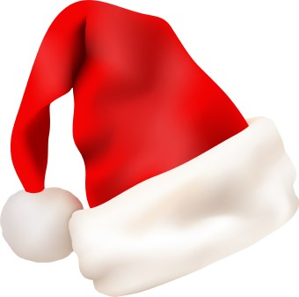

Christmas Quiz 2018

1. Where was Jesus born?  **Bethlehem**
2. Who wrote *A Christmas Carol*? **Charles Dickens**
3. What gifts were presented to baby Jesus?  **Gold, frankincense & myrrh**.
4. ‘*’The stars in the bright sky, Looked down where He lay’’*is a lyric from which festive song? **Away in a Manger**
5. What year did Slade top the charts with *Merry Christmas Everyone*?  **1973**
6. In the *Twelve Days of Christmas* how many Lords were Leaping? **10**
7. Do you know 3 other names that *Father Christmas* is known by around the world? **Saint Nicholas, Santa Claus, Kris Kringle**
8. In the song, *Good King Wenceslas looked out, On the Feast of .…* whom? **Stephen**
9. What year did Band Aid’s *Last Christmas* keep Wham’s *Last Christmas* off the top of the charts? **1984**
10. Can you name Santa’s eight reindeer? **They are Dasher, Dancer, Prancer, Vixen, Comet, Cupid, Donner, Blitzen, (Rudolph not an original).**
11. Who plays the drums in honour of Jesus?  **The little drummer boy**
12. Name the three kings that went to see baby Jesus.   
    **Caspar, Melchior and Balthazar**

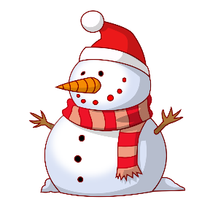

**For answers, please visit our Carers Centre website at** [**www.shetlandcarers.org/ChristmasQuiz**](http://www.shetlandcarers.org/ChristmasQuiz)