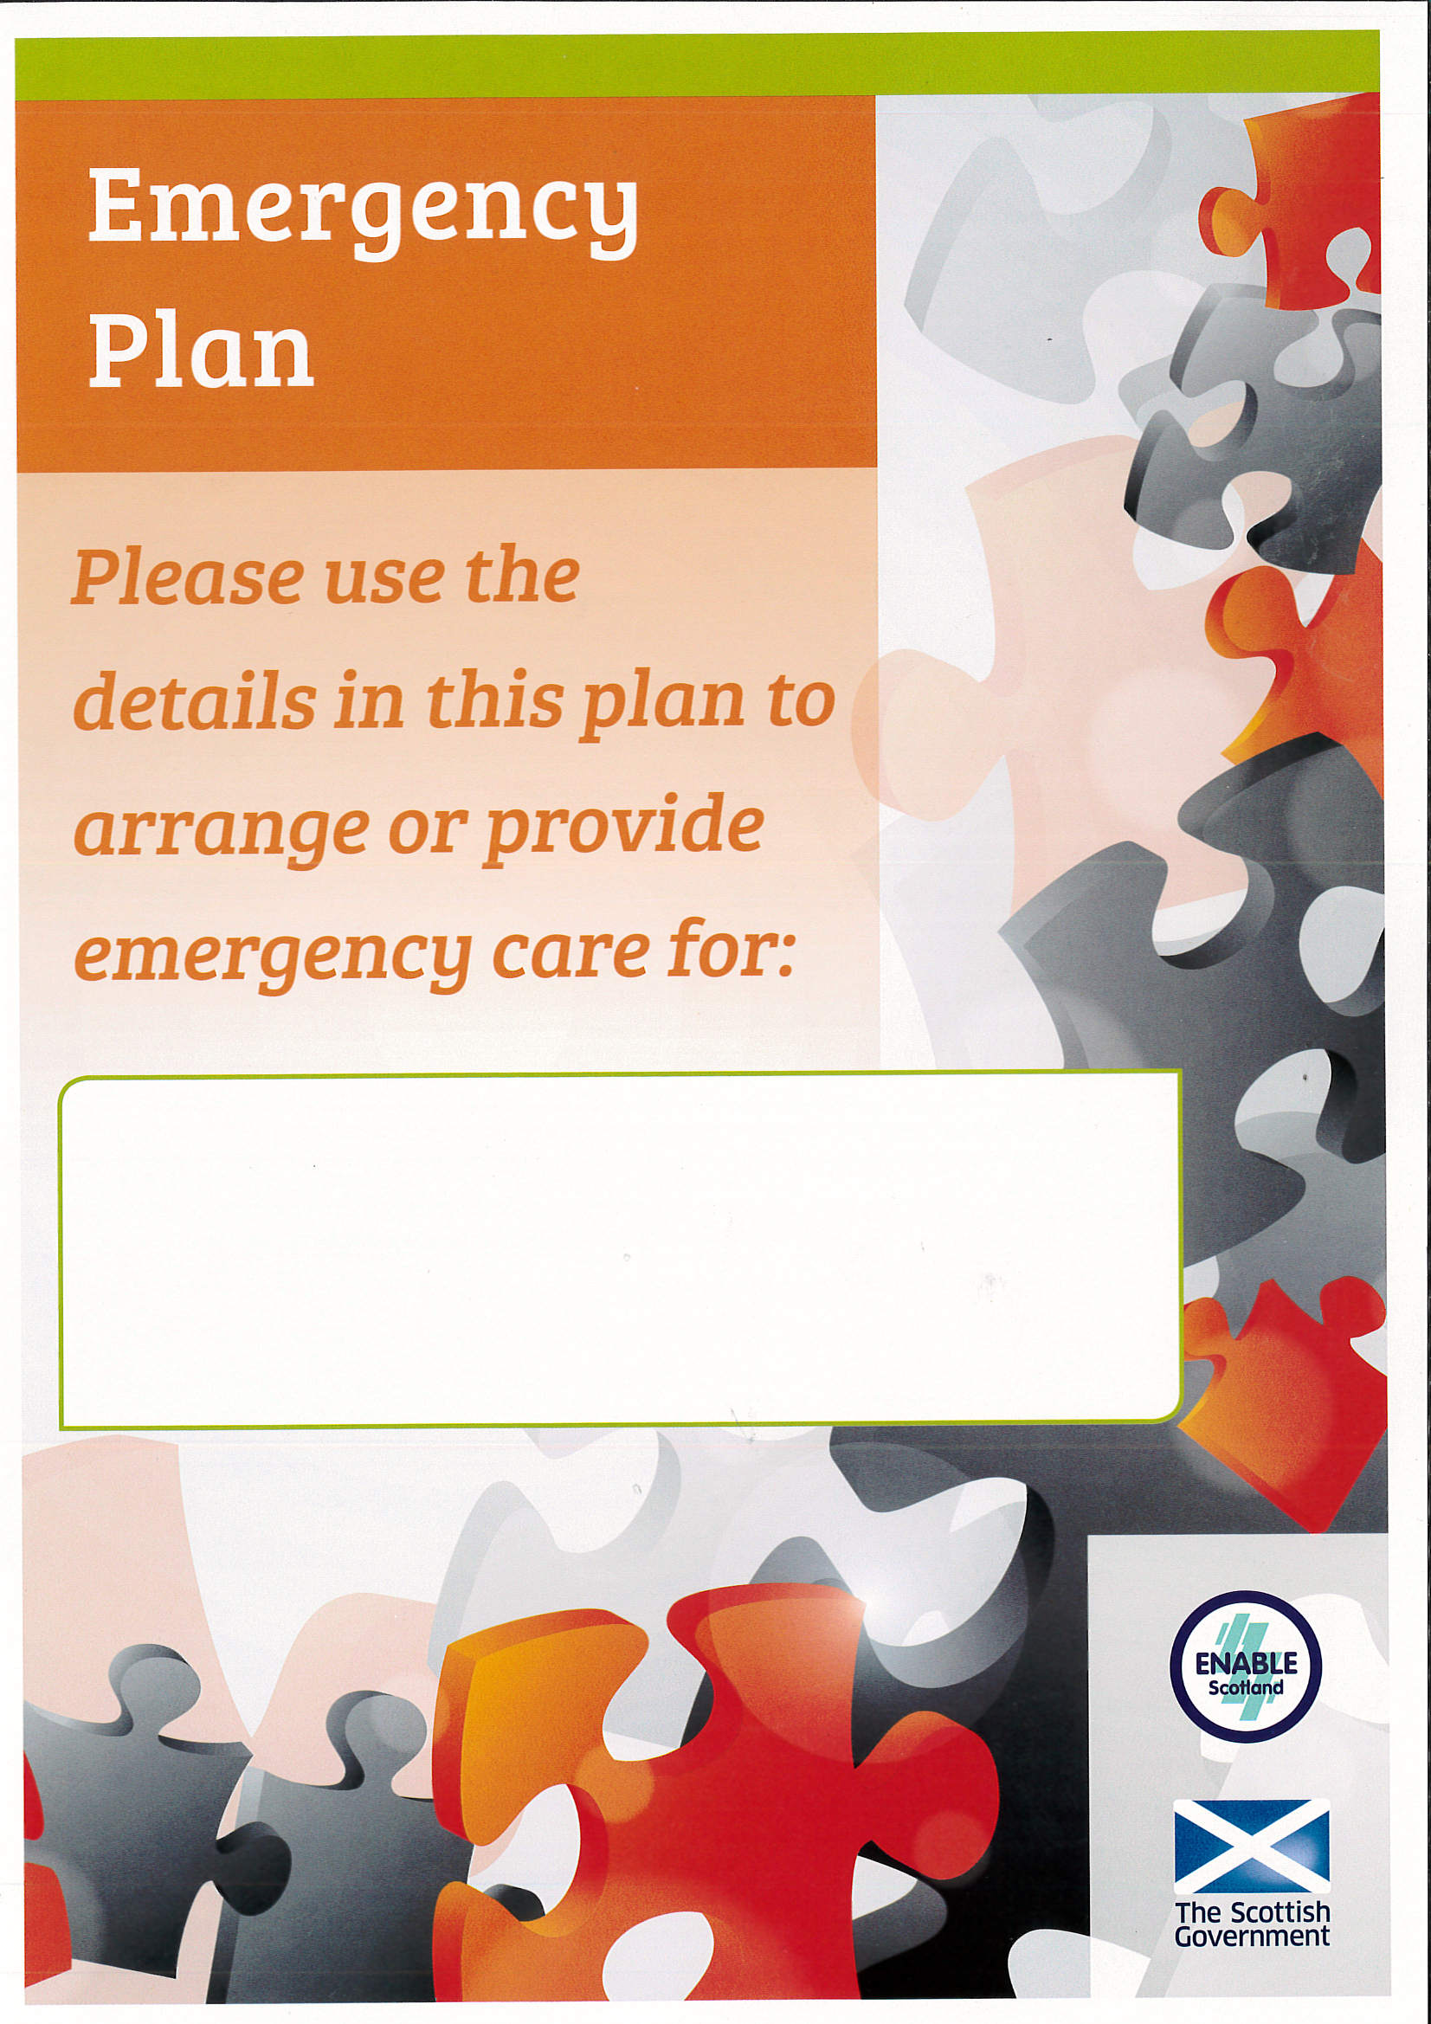
Neil Jones

Name
Neil Jones

Known as/prefers to be called
Neil

Address
Market House, 14 Market St, Lerwick, Shetland, ZE1 0JP

Date of Birth Religion/Faith
None
16/05/1949
Telephone numbers
01595 743 980
Next of Kin
Wife Maggie
Is a guardianship order in place? Please provide details
No
Is there a Power of Attorney? Please provide details
No
Likes Dislikes
Violence on TV. Daytime quiz shows on TV.
Looking at newspapers and magazines. Music, playing guitar – used to be in a band. Listening to grandson play fiddle. Talking about national service days. Politics

Personal Care
Neil has dementia and is able to carry out most personal care tasks for himself he does require prompting for everything.
Neil uses pads but often doesn’t put them in properly this can mean that Neil have the occasional “accidents” This can mean he has to change his clothes sometimes up to a couple of times per day.

Mobility
Neil’s mobility is poor, he needs to use sticks but does not like to do this so only uses occasionally. Neil does have difficulty in getting in and out of the car and needs support to do this.

Vulnerabilities
Neil is worried about other people looking after him and doesn’t have any respite services.

Triggers and strategies
Neil not being able to find Maggie can set Neil into a panic attack. Maggie says that by talking to Neil you can calm him down and reassure him by letting him know Maggie will be coming back.

Other

 | Morning | Afternoon | Evening
Monday - Sunday | Neil has porridge for breakfast, followed by a banana. He has tea, with milk and 2 sugars but does not like this to be very hot.  Neil takes 2 tablets in the morning (usually in a doset box ion top of the microwave). After breakfast Neil will sometimes go back to bed before he gets up and dressed.  Neil gets dressed by himself, he usually chooses his own clothes. Neil does use pads, but does not necessarily put them in properly.  About 11am they will have a cup of coffee and a biscuit / fancy. | 1pm is lunch time, they have their main meal at lunchtime. Neil likes soup, fish, and mince and tatties. He will eat most food slowly.  Neil loves puddings.  About 3pm they have a cup of coffee and choc biscuit. | 5.30pm they will have their tea, which can be boiled or scrambled eggs and toast, bread or rolls. Followed by a cup of tea.  8pm – cup of warm milk with a cracker or oatcake and butter and a fancy.  10.30 pm – Neil goes to bed after he takes his night tablet.  Maggie rubs ointment into Neil’s leg every night (he has a sore bit at the front of his leg)
Sunday | Likes to go to Methodist church at 11am and wear smart trousers and a shirt and jumper for this. | Likes to go out for a run if any Sunday Teas are on | Likes to watch Countryfile at 6pm on BBC1

Emergency Contact 1
Name | Kate Jones
Home Number | 01595 123 456
Mobile Number | 0777 777 777
Work Number | 01595 987 654
Relationship | Daughter
Keyholder? Yes/No YES |  |  | Keyholder? Yes/No
What help can they provide in an emergency?  Days/Times, care and support, transport etc. |  | Works full time but can come out in an emergency situation. Can help if Maggie needing a break and they have arranged this between them.  At weekends often takes her dad out for a run to get him out the house.
Please sign to acknowledge you have read this plan and can help in an emergency

Name
Address
Home Number
Mobile Number
Work Number
Relationship
Keyholder? Yes/No |  |  | Keyholder? Yes/No
What help can they provide in an emergency?
Days/Times, care and support, transport etc.
Please sign to acknowledge you have read this plan and can help in an emergency

Name
Address
Home Number
Mobile Number
Work Number
Relationship
Keyholder? Yes/No |  |  | Keyholder? Yes/No
What help can they provide in an emergency?
Days/Times, care and support, transport etc.
Please sign to acknowledge you have read this plan and can help in an emergency

Name
Address
Home Number
Mobile Number
Work Number
Relationship
Keyholder? Yes/No |  |  | Keyholder? Yes/No
What help can they provide in an emergency?
Days/Times, care and support, transport etc.
Please sign to acknowledge you have read this plan and can help in an emergency

Guidance

Health Conditions Allergies

Dementia
Angina
Sore on Leg

Where is medication kept?
The medication is all kept in a drawer in the kitchen. Maggie usually makes up the morning tablets into the doset box.

Name and address of pharmacy
Freefield Pharmacy

Name and address of GP
Dr Jamieson
Lerwick Health Centre, 27 South Road, Lerwick, Shetland, ZE1 0TG

Special Dietary Requirements
Doesn’t like brown or wholemeal bread

Support needed at mealtimes
Neil can feed himself but he does take a long time to eat

Alternative communication methods e.g. Makaton, British Sign Language, behaviour cues

Care Agency

Name

Address

Contact Number

Care provided (days, hours etc.)

Social Worker/ Care Manager
Name
Address

Contact Number

Other
Name
Address

Responsibility
Contact Number
Guidance
If you require any further additional Useful Contacts follow the steps below:
Highlight relevant table above
Select Copy
Click below this box
Select Paste
Move to new page if required
Repeat if necessary

This plan has been shared with the following agencies:

Other relevant information

Pets in household (if applicable)
Name | Species | What are the emergency care arrangements?



