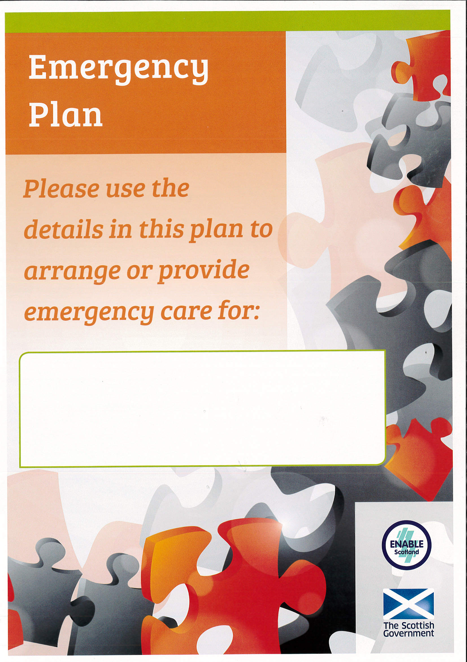

Name

Known as/prefers to be called

Address

Date of Birth Religion/Faith

Telephone numbers

Next of Kin

Is a guardianship order in place? Please provide details

Is there a Power of Attorney? Please provide details

Likes Dislikes

Personal Care

Mobility

Vulnerabilities

Triggers and strategies

Other

 | Morning | Afternoon | Evening
Monday
Tuesday
Wednesday
Thursday
Friday
Saturday
Sunday

Emergency Contact 1
Name
Address
Home Number
Mobile Number
Work Number
Relationship
Keyholder? Yes/No |  |  | Keyholder? Yes/No
What help can they provide in an emergency?
Days/Times, care and support, transport etc.
Please sign to acknowledge you have read this plan and can help in an emergency

Guidance
If you require any additional Emergency Contacts follow the steps below:
Highlight table above
Select Copy
Click below this box
Select Paste
Move to new page if required
Repeat if necessary

Health Conditions Allergies

Where is medication kept?

Name and address of pharmacy

Name and address of GP

Special Dietary Requirements

Support needed at mealtimes

Alternative communication methods e.g. Makaton, British Sign Language, behaviour cues

Care Agency

Name

Address

Contact Number

Care provided (days, hours etc.)

Social Worker/ Care Manager
Name
Address

Contact Number

Other
Name
Address

Responsibility
Contact Number
Guidance
If you require any further additional Useful Contacts follow the steps below:
Highlight relevant table above
Select Copy
Click below this box
Select Paste
Move to new page if required
Repeat if necessary

This plan has been shared with the following agencies:

Other relevant information

Pets in household (if applicable)
Name | Species | What are the emergency care arrangements?

