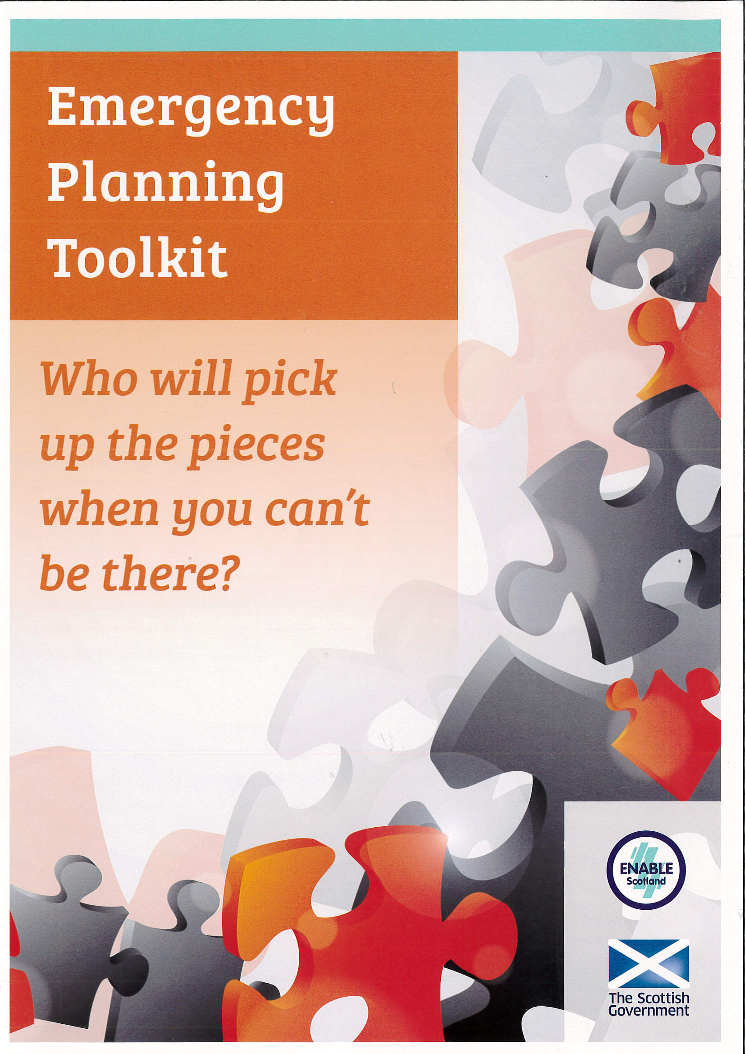

Introduction

Care? Prepare. Plan! Share…

Emergency Planning Toolkit – for carers and professionals

This toolkit will help carers to create an emergency plan. Carers will be encouraged to answer the; who, what, why, where, when and how of planning for those unforeseen circumstances. The toolkit can be completed over a period of time to support the development of an emergency plan for carers and the individuals they care for.

Carers working their way through the toolkit will be advised to consider all eventualities and possible solutions. The toolkit encourages carers to involve all relevant family, friends and professionals in the process.

At the start of each discussion point you will find: useful definitions, links to further reading, guidance and anecdotes.

By planning in advance, with the hope that the plan never has to be used, carers can record their knowledge and expertise on paper which will ease the transition if someone needs to step into their caring role in emergency.

Professionals can use the toolkit to inform the discussions they have with carers about emergency planning.

Each emergency plan is unique. This toolkit will help carers and cared for individuals to explore the plans they need to put in place. On completion of the toolkit, carers should be ready to finalise their emergency plan.

Guidance
Please note that all text boxes will expand when you begin typing into them.

Guidance
The carers (Scotland) Bill says that a carer is “an individual who provides or intends to provide care for another individual”

What is an emergency?
An emergency is an illness, personal crisis or event which, unexpectedly, or at very short notice, results in either the carer being separated from the cared-for person on a short or long term basis or in the escalation of the cared-for person’s needs. It could include a family funeral, a transport delay, family illness, admission to hospital, last minute doctor or dentist appointment or a personal incident affecting the carer.

What is an emergency plan?
An emergency plan sets out the practical arrangements for short term, unplanned circumstances when the carer is unable to fulfil their caring role. An emergency plan is a written document.

What we know about benefits of emergency planning:
Carers who have put an emergency plan in place tell us that the emergency plan has given them peace of mind because they know if an emergency happens, the person they care for will be looked after. We recommend planning at the earliest possible opportunity as, by their very nature, emergencies are unpredictable.

For more information visit:
www.enable.org.uk/emergencyplanning

Who do you care for?

What do you know about emergency planning?

Guidance

An emergency plan should help you to identify the people who are already in your life that that can help with caring in your absence – this could be friends, family, neighbours or anyone else who knows you and/or the person you care for.

You might need to have individual conversations with potential emergency contacts or you could try getting everyone together to talk it through. Make sure you involve the cared-for person, if and when you can.

You will need to tell everyone what an emergency plan is and why you want to make one. You will also need to speak about what care the person needs. Ask them to think about how they might be able to help in an emergency.

Check if those individuals are willing to be listed on the emergency plan as an emergency contact. Explain that there is no obligation for them to agree to be an emergency contact, but, if they do, it is a commitment. Peace of mind can only come from the assurance that people in the plan will respond in the carer’s absence.

Who will you involve in your emergency plan discussions?

Guidance
Think about what an emergency plan would mean to you and the person you care for.
“I have a plan in my head”

Think about what would happen in an emergency if you didn’t have a plan. Are there friends, family, neighbours that you expect would step in? Are they aware of this expectation? Have you discussed the individual’s care needs with them?

How would hospitals, police, social work, or whoever comes across the emergency know who to contact and how to contact them?

How would the person you care for feel about going into emergency respite care or hospital?

The aim of the plan is to create an informal network of support around the carer and cared-for individual. This, in turn, prevents the need for crisis local authority care. If an emergency occurs, you can be safe in the knowledge that a person(s) you know and trust is stepping in to your caring role and the person you care for can be reassured by the presence of someone familiar.

An emergency plan can prevent an emergency becoming a crisis.

Why are you creating an emergency plan?

How will this help you and the person you care for?

Guidance
We talk about emergency plans providing peace of mind for carers. This is because many carers have told us that the health and wellbeing of the person they care for is more important to them than their own.
“If he is happy, I’m happy”

However the purpose of the emergency plan is to make sure someone can step in to your caring role in your absence. The plan is about the person you care for, detailing who can provide emergency care and giving information about what care the individual needs. As such, the person you care for should be involved in the process wherever possible.

Some ideas for making the plan process more accessible include:

Using pictures and photographs
Smaller discussions if large crowds are an issue
Advocacy
PAs/Support Workers
Talking Mats
Providing choice where possible

Will the person you care for be involved in this process?

If not, why not? How could they become more involved?

Guidance
Think about all of the care and support you provide.

It might help to think about an average day – from when you both get up until you go to bed at night.

Is overnight care required?

The more detail you can include, the easier it will be for someone else to step into your role with minimal disruptions.

Would the inclusion of a daily timetable be helpful?

Is any care provided by an external agency? What days do they provide care or support? How many hours?

What care and support does the person you care for need?

What is the cared-for person’s routine?

Guidance
With regards to medication, we recommend pharmacy packed dosette boxes or blister packs as they reduce the likelihood of medication being administered incorrectly.

Are there specific times for medication to be administered?

Is there a protocol for any specific health or case issues – for example an epilepsy protocol, or guidance about ‘as required’ medication or a moving and handling protocol.
Where is this kept?

Does the individual have specific/complex health or care needs that require specialist input or training? If so, we recommend speaking to the care manager/social worker about what would happen in your absence.

What are the healthcare needs of the person you care for?

What allergies, if any, does the person have?

Where is the medication kept?

Guidance
Think about food and drink that the cared-for person likes and dislikes
Do they take their tea and coffee a certain way?

Does food need to be cut up for the person?

Does the person require support at mealtimes with feeding?

Does the person follow a specific diet, for example, vegetarian?

Are there any specific dietary requirements or food preparation requirements in relation to the person’s faith or culture?

What are the dietary requirements of the cared-for person, if any?

What support does the person need at mealtimes?

Guidance
Does the person use an alternative communication method, for example Makaton, British Sign Language, pictorial aids?

Are there behavioural cues that would be helpful to an interim carer to be aware of?

Are there specific vulnerabilities, for example, traffic awareness or short-term memory?

How should the emergency contact approach certain situations? Are there things he/she should or shouldn’t say?

Are there things he/she should or shouldn’t do?

How does the person communicate?

Guidance
What are their contact details?

Are they listed in order of preference?

Are there certain days they can/cannot help?

Who is able to stay overnight, if required?

Would they provide care in your home, the home of the individual (if different) or in their own home?

Do you need to provide keys to all emergency contacts?

Is there a key safe? If so, who has a key?

Are there pets in the property and, if so, have arrangements been made for them in an emergency?

Are there any potential issues in relation to pets, for example, safety risks to emergency/interim carers?

Who are you emergency contacts?

How will they access the house?

Guidance
In an emergency situation, those responding may need to know who is legally responsible for the person you care for – of course, this might be you!
A list of contacts that might be useful in an emergency could include:

GP/health centre
Social worker/care manager
Pharmacy
Support provider

Who is the cared-for person’s next of kin?

Does the person you care for have a Power of Attorney or guardian?

Who are the main agencies or professionals involved and how can they be contacted?

Guidance
The emergency plan is for the person you care for.

Do you want to include personal information about the person you care for? Date of Birth? Religion or faith?

Emergency contacts may be family and friends who know the person well however they might not know their care needs as they do not perform this role day to day.

Emergency contacts would welcome as much information as possible to allow them to step into that role. This will make the transition much easier for the emergency contacts and the person you care for.

This will also reduce the anxiety for you should an emergency occur as you will know that you have passed all relevant information to ensure the safety, care, support and happiness of the person you care for in your absence.

Is there anything else that you think it would be important to include in the plan?

Guidance
An emergency plan can only be effective if people know about it.

The plan should be shared with everyone that has agreed to be an emergency contact and ideally they should sign the plan to confirm that they have read it.

Furthermore, the plan should be shared with social work and all other professionals who are involved with you or the person you care for.

You should also consider who may be likely to ‘raise the alarm’ if an emergency occurs. It is important that these people know that you are a carer and that they know that an emergency plan exists.

You may not want everyone to have a copy of the plan – especially as it will contain sensitive information about the person you care for. However, you should consider where the plan will be kept and make sure that the relevant individuals know its location.

Who will you share the plan with?

ENABLE Scotland
http://www.enable.org.uk/emergencyplanning

Care Information Scotland
http://www.careinfoscotland.scot/topics/how-to-get-care-services/emergency-and-future-planning/

Carers UK
http://www.carersuk.org/help-and-advice/practical-support/planning-for-emergencies

Help with planning:
Your local carers centre or social work department may be able to help you complete your emergency plan.

ENABLE direct can provide you with information on carers’ services, including emergency and future planning, in your area.
T: 0300 0200 101, E: enabledirect@enable.org.uk
