
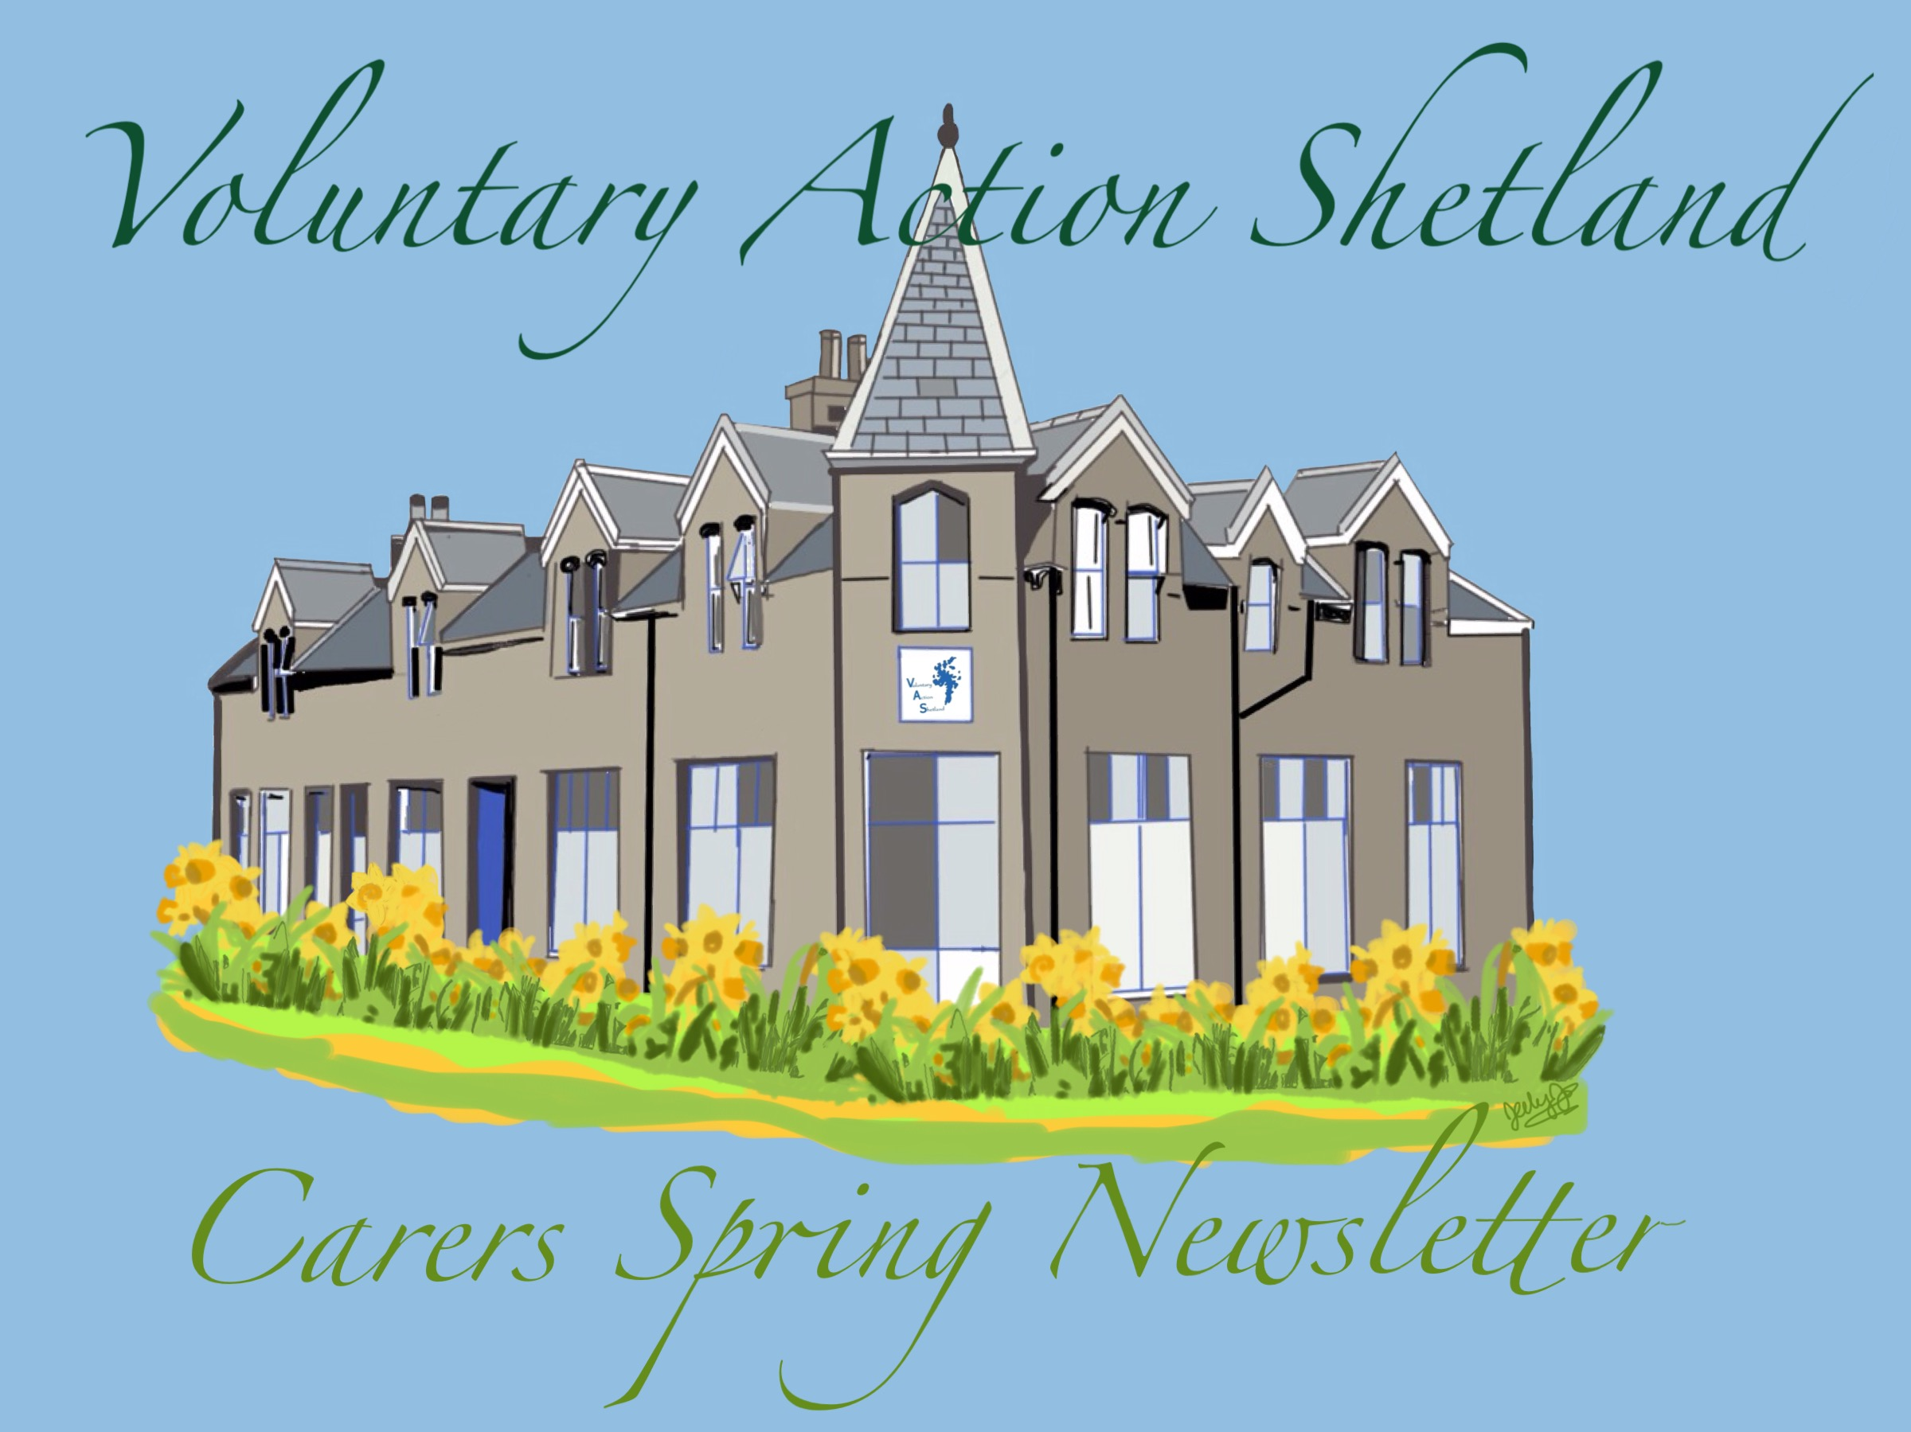
Hello everybody! We are happy that the days are getting longer, and to be sharing the VAS Carers Spring Newsletter with you. It has been a busy winter, and we have been hearing feedback from many carers in Shetland, which helps with programme development to meet your needs.

Thank you to the carers, statutory and third sector partners who participated in the scoping exercise! Several of the new VAS carers programmes such as the Parents Plus Support Group, and the Siblings Saturday Club are a direct result of carers expressed needs. The Scoping Report will be available on the Virtual Carers Centre shortly www.shetlandcarers.org
.
In this newsletter, we are happy to have information from other community organisations in Shetland who support carers and their care recipients. We hope you enjoy the addition.

We always welcome feedback and comments from carers on any issue. You can contact us via the Virtual Carers Centre - www.shetlandcarers.org, email jo.mcpherson@shetland.org, phone 01595 743923 or Like us on Facebook: ShetlandCarers.

Short Breaks Funding

We were fortunate enough to receive another year's short break grant funding from Shared Care Scotland. The idea behind this grant is to enable carers to get the short break of their choice. The average grant is £200 per carer plus mileage. In the past carers have used this grant for spa sessions in Bressay, haircuts and pamper sessions, towards a holiday, cinema visits and horse riding. The grant is for you to use in any way that you feel would benefit you. If you would like to access this grant you can do so online at the virtual carers centre www.shetlandcarers.org or by calling Jo at 01595 743923. This is an annual grant so if you applied to the previous round you can now reapply.
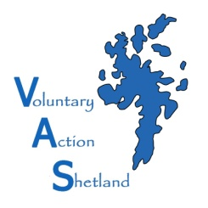
Carer's Assessments

VAS is now offering carers assessments through a pilot project with SIC. A carers assessment is a way of identifying your needs as a carer. They look at your role as a carer: how being a carer affects you, how much caring you can realistically do (while still allowing you to be involved in activities outside caring), and any help you may need. Carers of all ages who provide regular and substantial care are entitled to a carer’s assessment, although for young carers this may be carried out through GIRFEC, under the Children (Scotland) Act 1995.
ELECTRONIC NEWSLETTER AVAILABLE!

If you are interested in receiving your newsletter via email, we can do that!

Contact us with your email address
and we will send you a copy.

The most recent newsletter will also be available on the Virtual Carers Centre www.shetlandcarers.org

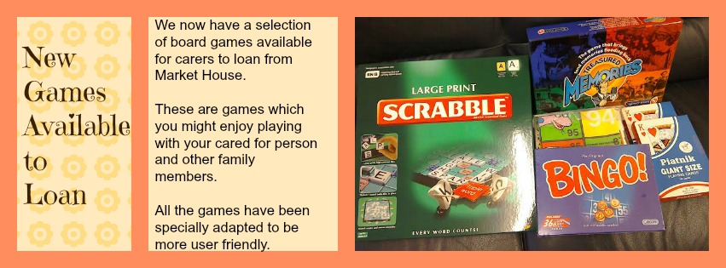
We can visit you at home to chat over your assessment or make an appointment at the carers centre in Lerwick or at another suitable venue. We work on behalf of
unpaid carers and often find that by meeting with you to look at an assessment we identify together other areas where we can help find the information you require for you or can signpost you to an organisation that will help. For more information or to receive a carer's assessment, please contact Jo 01595 743923 jo.mcpherson@shetland.org

The Carers (Scotland) Bill
In October 2013, Alex Salmond MSP, the then First Minister of Scotland announced that the Scottish Government would bring forward specific legislation to promote, defend and extend the rights of carers and young carers.
A consultation paper on the proposed carers legislation was published on 22 January 2014 and closed on 16 April 2014. The responses informed the Carers Bill that is to be introduced to the Scottish Parliament. There were 165 responses from organisations and individuals and 1,422 generated by surveys distributed by two stakeholder organisations submitted to the Scottish Government.
The consultation sought views on a number of matters for carers and young carers. These included renaming carers assessment Carers Support Plans and removal of the substantial and regular test as eligibility for assessment.

The following Briefing papers have been produced by the Coalition of Carers in Scotland and are available free to download:
The Carers (Scotland) Bill was introduced to parliament on the 9th of March. This briefing paper provides a summary of the provisions within the Bill. It also gives an analysis of which areas reflect the views of the majority of carers, which areas need strengthening or go against the views of carers and where provisions need to be added. You can download a copy here: The Carers (Scotland) Bill – a briefing paper for carers
This briefing paper explains the legislative process and how a Bill makes its way through parliament. It also explains what happens once it becomes law and how carers can get involved and influence the parliamentary process. You can download a copy here: Understanding how law is made – A guide for carers
Coalition of Carers in Scotland

Unpaid Carers provide more support to people with care needs than the entire health and social care workforce. This significant role has long been recognised by government, yet until now they have not had any right to support to assist them in their caring role.
We are delighted that the Scottish Government will be bringing forward legislation exclusively for carers, for the first time. We hope the Carers Bill will deliver clear and enforceable rights to carers, will end the postcode lottery which carers currently face and will enable them to access timely, quality support when they need it.
Carer Quotes:
'We need common sense legislation that ensures equality and maintains standards of support' (carer, North Lanarkshire
'I feel it is important that a Duty is placed on the local authorities to recognise the role I play and should provide me with appropriate supports which meet my needs' (South Asian Focus Group)
'There is a need for Carers Legislation to ensure carers are seen as a priority in Scotland' (carer, South West Glasgow)
'Carers provide a vital service and, like the paid work force, should have rights and entitlements to enable them to continue to care without risk to themselves' (Carer, COCIS meeting)
'The duty to provide short breaks linked to a requirement to produce a statement of short breaks availability at last brings clarity for carers to an otherwise confused situation' (Carer, COCIS meeting)

Your Voice Counts!
Representation for Unpaid Carers

The carers’ representative on the Shetland Integration Joint Board (until April the Shetland Community Health Partnership) is Sue Beer. The Integration Joint Board makes decisions about how health and social care services are planned and delivered for the community in Shetland. If you have any carer issues that you would like her to bring before the IJB/CHP you can contact her at sue.beer@shetland.org

Sue also represents rural and island carers on the Scottish Government Carers Reference Group, see http://www.scotland.gov.uk/Topics/Health/Support-Social-Care/Unpaid-Carers/CarersReferenceGroup (or Google Carers Reference Group) for more information.
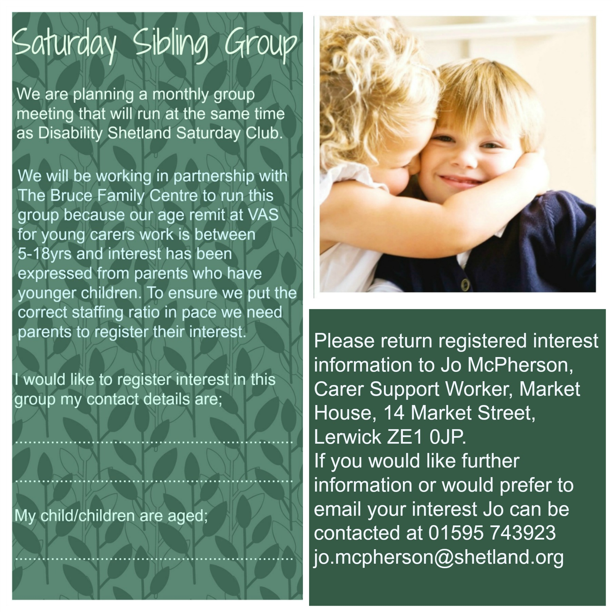
She is on the remote and rural group of

the Coalition of Carers in Scotland, http://www.carersnet.org/ which also helps to shape Scottish Government policy. Following recommendations to Sue and another representative of this group by Nicola Sturgeon, who met with a group of carers in November, the two of them have also joined the Rural Parliament, as many issues faced by Shetland carers are largely governed by where they live.

Sue is very happy to do her best to put forward your concerns. If you can’t email them, you can call her on 01595 743909, and leave a message with your number. If she isn’t there, she’ll get back to you or you can put your ideas or issues to Jo or Karen either at carer group meetings or by using the contact us on the virtual carers centre www.shetlandcarers.org and they will ensure that Sue receives them.
Voluntary Action Shetland is looking for Carers who would be interested in being part of a Pilot Project. The project would see The Open University in Scotland (OU) and VAS Carers Centre staff support carers to undertake the Caring Counts course.

CARING COUNTS

Caring Counts was developed with and for carers and is a self-reflection and planning course suitable for anyone who is in a caring role or situation. The course will enable carers to reflect on their caring journey and identify the skills and abilities they have gained and continue to gain in their caring role.

The course features the stories and experiences of a range of carers from very diverse backgrounds and caring circumstances, who share their lives in text and on film. Users have the option of completing a series of quizzes to gain a digital badge marking their achievement in completing the course.

This course is for carers of any age and at any stage in their life or caring role and it is flexible as it can be on or off-line.

As well as helping carers recognise and value their skills and experiences and suggest opportunities for learning and other ideas for personal development, the course includes detailed information about career planning for those thinking about employment, or those thinking about returning to work and/or study that they may have had to put on hold.

The Pilot would create focus groups for participants to share and enjoy peer support between meetings. These can be both be face to face study buddy

groups and virtual on-line groups who enjoy peer support via social media.

Carers will also be invited to be involved in the Evaluation of the project.

If you are interested in taking part in the pilot then please contact Kirsten Harcus 01595 743980 kirsten.harcus@shetland.org
For further details please contact Kirsten Harcus or visit www.openuniversity.co.uk/scottishcarers


The 60+ section of the befriending scheme has been open for referrals Shetland wide since January 2012. The aims of the 60+ section are to help those aged 60 and above, and to reduce their feelings of isolation. Its about encouraging their ability to continue to be as independent as possible, to increase better social connections and social contact within their community and to increase positive mental health and well being and feelings of positive self worth.

60+ adults can either self refer or ask a member of the family, a friend or a community care professional to support them to refer to our service. We would welcome referrals from adults aged 60+ years, who are currently living in their own home, who are significantly socially isolated, who have very limited/no support around them and who may be experiencing a period of significant loss or change in their lives.

Demand for the service always exceeds available volunteers however the service will try their best to find matches for anyone who is on the matching list. The service is just about to start training a new group of recruited volunteers who hope to be matched before the summer months.

Volunteers are matched with a 60+ adult who they have similar interests with, live relatively near, are likely to get on well together and are available at the times the 60+ adult wishes to have a meeting. Meetings can be either once a week or fortnightly for an hour or a few hours depending on what the 60+ adult and volunteer agrees to do. 60+ adults are generally saying that they would love to go for car runs, go out for lunch or to Sunday Teas, go to a concert, go out for a walk, or engage in a local community event.

We would love to hear from anyone who would be interested in accessing the scheme either for themselves or for someone they know. We would also be interested in anyone over the age of 18, wanting to volunteer for the service.

Volunteers receive free training, activity and mileage costs and on-going support and supervision from the scheme.

For further information, please telephone Elaine Mouat or Pauline Mackie, 60+ Development Workers on: 01595 745898 743908 or email elaine.mouat2@shetland.org pauline.mackie@shetland.org

Also check out our website for further information:
http://www.shetland-communities.org.uk/subsites/shetland-befriending

You can also find and “Like” us on Facebook.



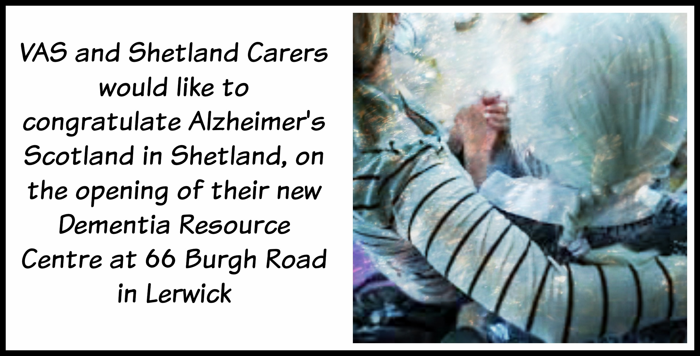
April 17th will see the opening of Alzheimer Scotland’s Dementia Resource Centre in Shetland.

Situated at 66 Burgh Road Lerwick , the building will serve as a Drop In for anyone seeking information about dementia, as well as a base for the Dementia Advisor, Ann Williamson and the Community Activities Organiser, Laura Whittall.

The Centre has been refurbished to encompass many Dementia Friendly features and is designed to offer practical examples of ideas to maintain independent living to families and individuals living with dementia.

Henry Simmons, CE of Alzheimer Scotland will be travelling to Shetland for the opening.
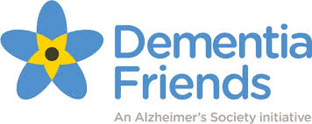
Dementia Friends

DF is described as a Social Action Movement and is all about raising awareness and reducing stigma

around dementia and is delivered by Ann Williamson, Dementia Advisor for Shetland.

It comprises of a training session of approximately one hour, which is designed to be interactive and informative.

5 key messages about dementia will be brought to life through a number of activities.

At the end of the session, the individual will be asked to sign up as a Dementia Friend and to state their ‘Call to Action’ which is something they will take away to implement in a way which will continue to raise awareness and begin to create a dementia friendly community.

It can be something as simple as talking about being a Dementia friend or not becoming impatient in the supermarket queue if someone is having difficulty.

The training is open to groups, businesses, individuals and the more people who become DFs, the closer we move to becoming a dementia friendly island.

For more information you can also go to the website www.dementiafriends.org.uk

VAS Carer Groups
News from North Isles carers groups
We have had a busy few months with a carers residential in December, a fun workshops on basket making, lunchtime meeting at Belmont House with visiting inspection team members discussing access to services in the Isles and our Parents plus group meetings.

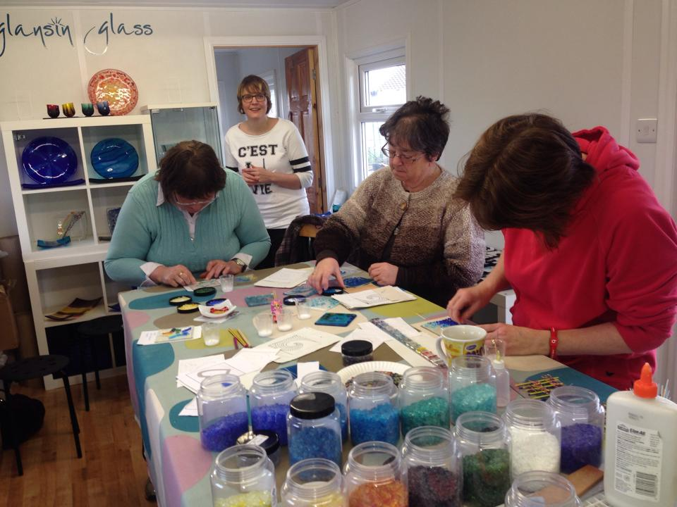

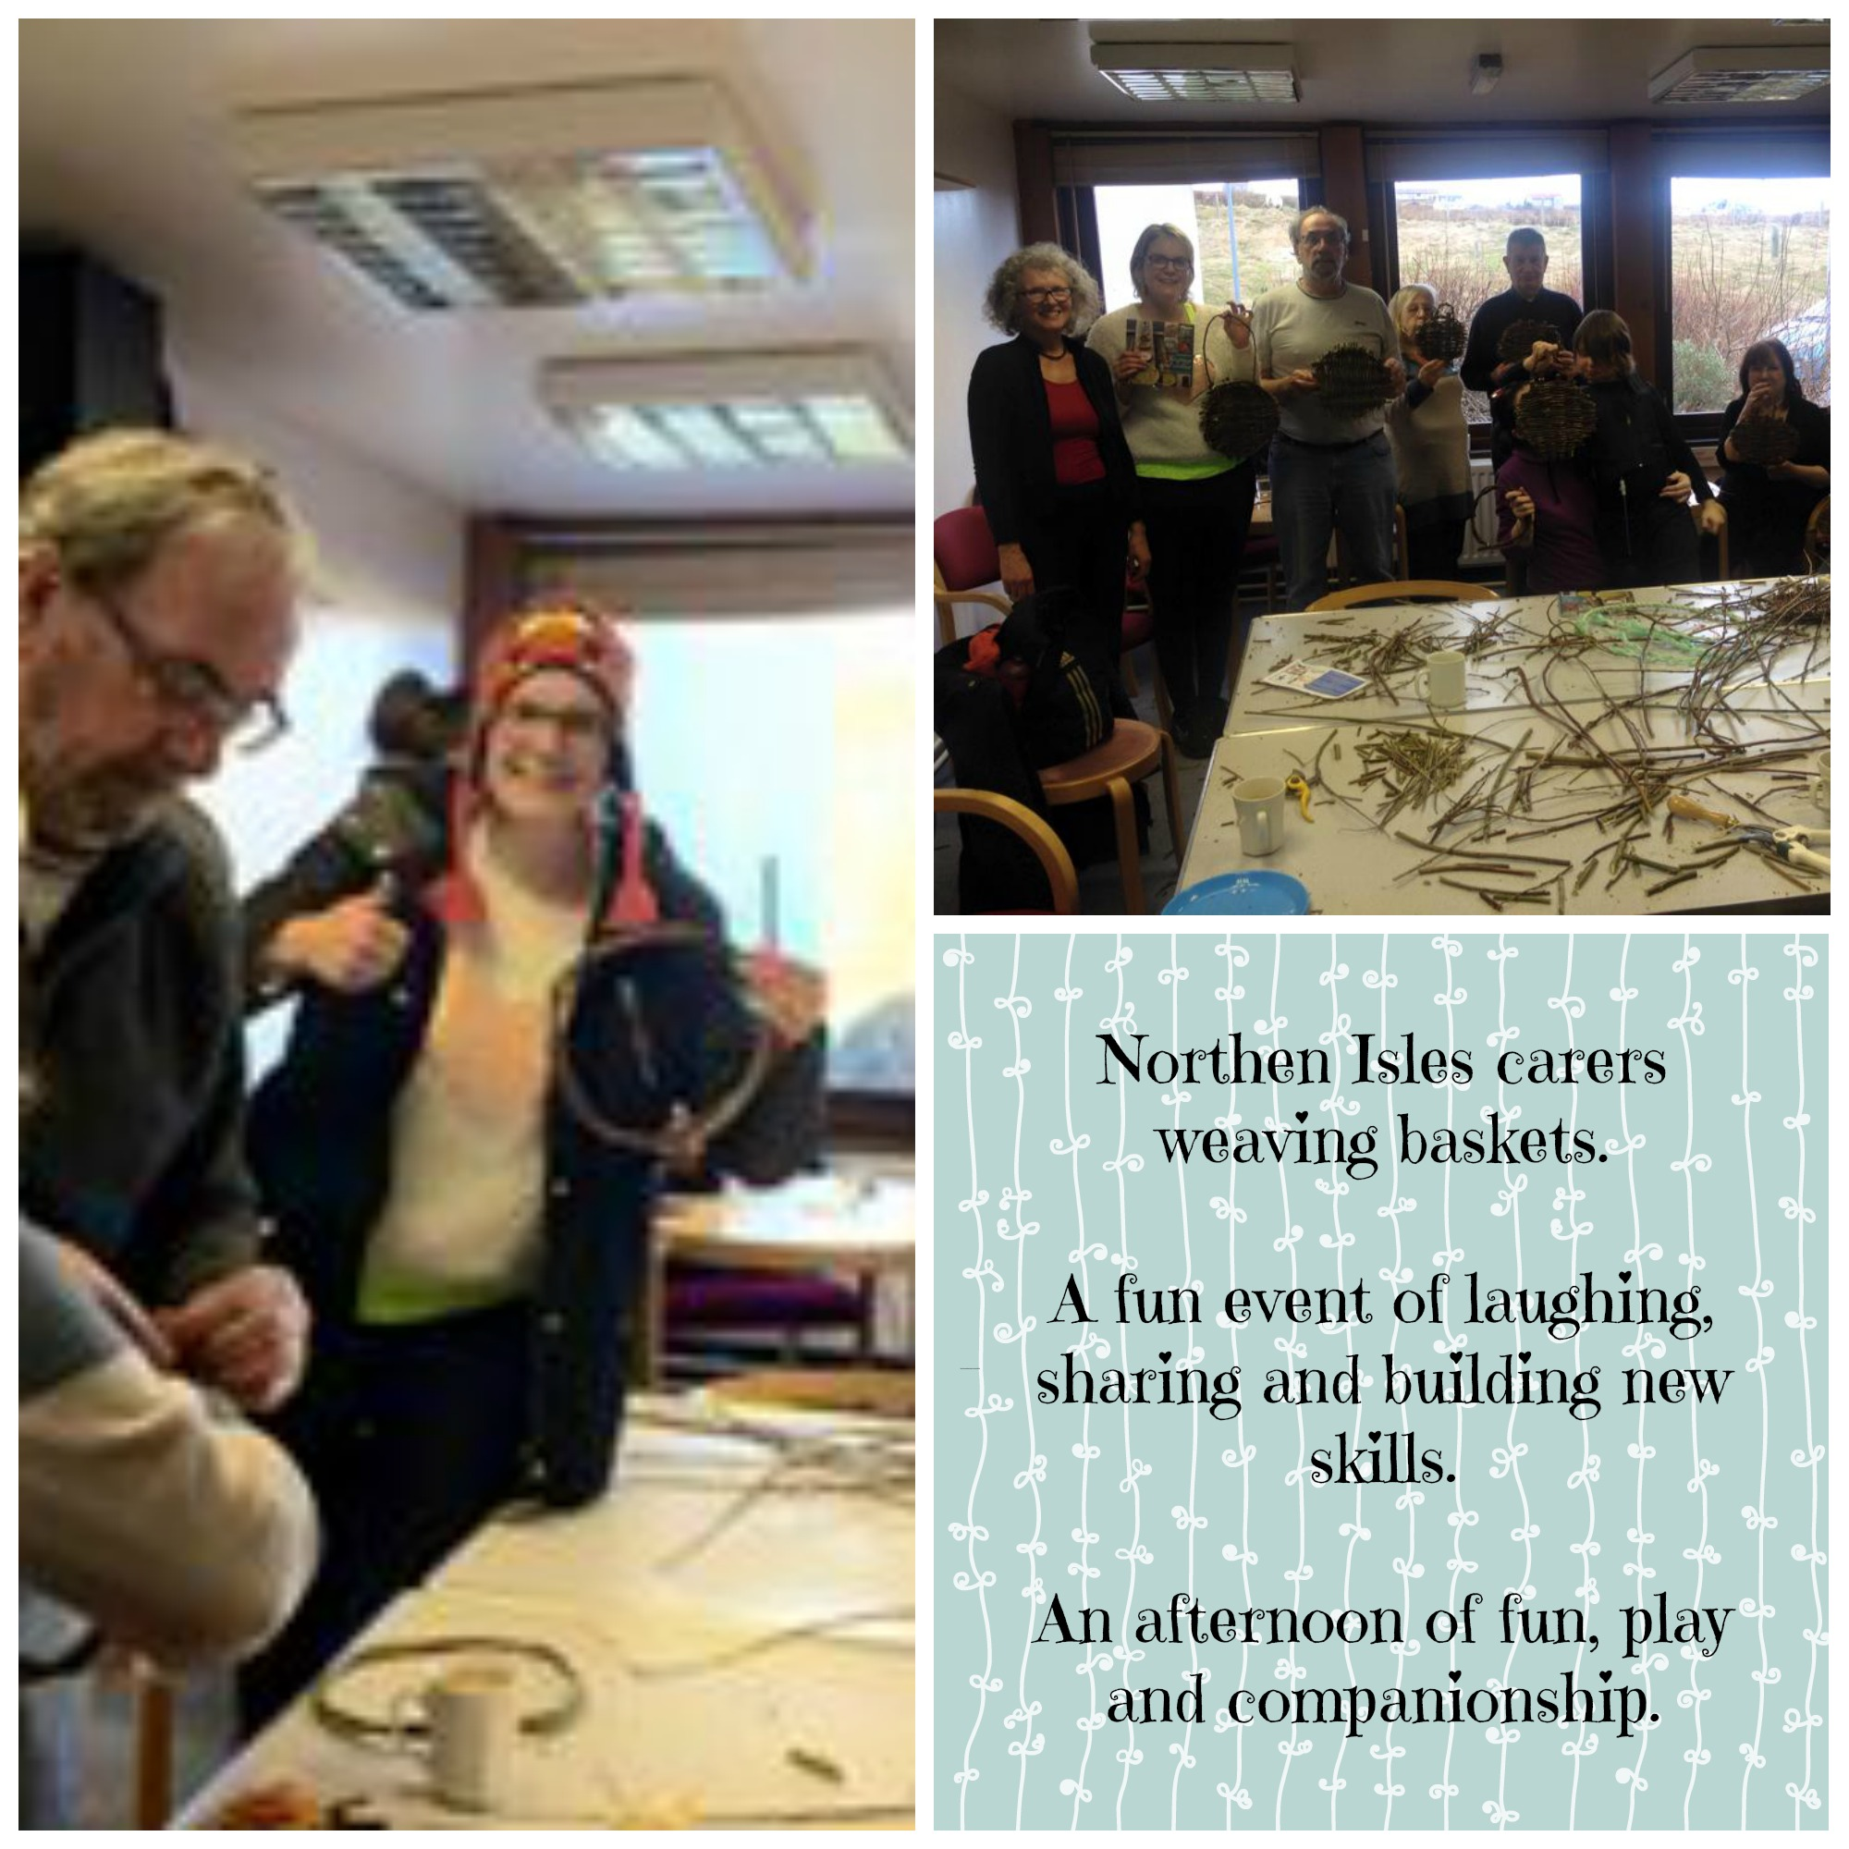

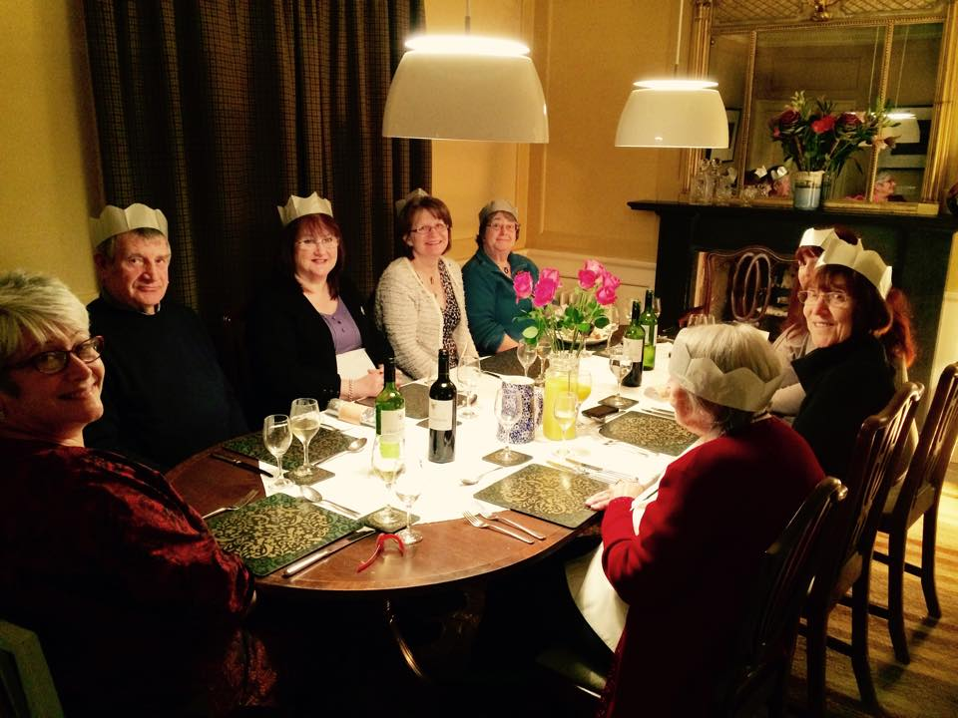

Lerwick, Crafty Carers
This group meets in the carers centre, Market House, Lerwick to enjoy a cuppa, chat and making arts and crafts.

