VAS CARERS SUPPORT SERVICE

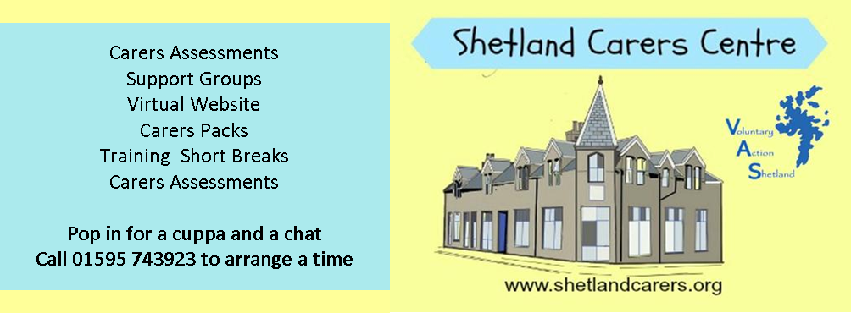

CARER’S FEEDBACK DATABASE INFORMATION 15/10/2015

- Please can you add your details and return to us in the enclosed prepaid envelope. We keep a database of Carers to enable us to provide information about services appropriate to your caring role, for example information on short breaks and our quarterly Carers Newsletter.

Name | Address | Email

Tel Number | Mobile | Date of Birth

Relationship to Care Recipient | Cared for Persons Name | Date of Birth of Cared  For Person

Reason for Requiring Care | Have you had a Carers Assessment / Carers Support plan? | Would you like a Carers Support plan?
- (i) What type of support are you interested in receiving from VAS Carers Service? Please tick all that apply
Newsletter |  | Short Break
Support Group |  | Carers Support Plan
Training |  | Website
Signposting to other services |  | Advice about benefits / money /
Young Carers Support |  | Appointment based drop in
Keep Well Health Check |  | None

(ii) Please tick here is you would like to discuss your caring role in private with a member of staff from VAS Carers Support Service □

(iii) Please tick here if you would like to receive our Newsletter by email
YES |  | EMAIL ADDRESS

(iv) Would you be interested in any of the following through the Virtual Carers Centre Website? Please tick all that apply
Live Chat |  | Question and Answer Session
Podcast (eg. A presentation that can be downloaded) |  | Online Discussion Forum

(v) I would need help with accessing the internet □

(vi) We are looking at ways of making our carers support groups more inclusive.
If you would like to attend a carers group, please tick which one you would prefer

To come to the group on my own for time out for me
To come to the group with the person I care for

- (i) Would you attend an event in Shetland organised by VAS Carers Support Service for Carers during Carers Week?
YES |  | NO

(ii) If no, why not? (then please continue to Question 4)

(iii) What kind of event would you like to attend? Please tick all that apply

Information Session by service providers to help you in your caring role |  | Workshops with service providers about future service development
Time out from caring – fun activity, eg, bowling, watching a film |  | Time out from caring – relaxing activity, eg. Reflexology
Time out from caring – project activity, eg arts and crafts, making something on the day |  | Time out from caring – pampering session eg manicure
Morning Event |  | Afternoon Event
Full day event with lunch provided |  | Please share any other ideas

- Where would you be willing to attend an(y) Event(s) to celebrate Carers Week? Please tick all that apply
Lerwick |  | Central Mainland
South Mainland |  | West Mainland
North Mainland |  | North Isles
- Can you think of anything else we should consider when planning our next Carers Week local Event ?

- Any other comments VAS Carers Support Service in general

Thank you very much for your help.

