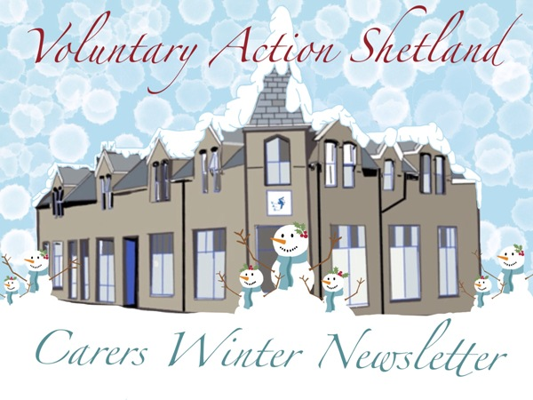

CARERS RIGHTS DAY
To mark Carers Rights Day on 19th November we held our first ever Live Question and Answer Session through our Virtual Carers Website. This went well with several individuals making contact to ask us specific questions relating to their caring role, including information about respite, short breaks and carers Support Plans (formerly assessments). To view the all questions and answers please visit http://www.shetlandcarers.org/qa and click on View Event.
Carers Scotland have produced A Carers Rights Guide 2016 which can be downloaded free from https://www.carersuk.org/scotland/training-resources/carers-rights-guide-scotland. Or if you do not have access to internet please contact us for a paper copy of the Guide.
Due to the success of the first session we are holding another Live Question and Answer Session on Friday 22nd January from 11 - 12. This will provide an opportunity for unpaid carers to ask any questions about their caring role and hopefully we will be able to offer some help for you. Clint Sentence, Telecare Project Manager will be our guest and he can answer any questions you may have on Telecare and Community Alarms. To join the event please click on http://www.shetlandcarers.org/qa


SHORT BREAK FUND We are still taking applications from carers for our short break grant funding from Better Breaks. The idea behind this grant is to enable carers to get the short break of their choice. If you would like to access this grant you can do so online at the Virtual Carers Centre website at www.shetlandcarers.org or by calling Karen.

CARERS LINK GROUP & CARERS REP
The Carers Link Group is a multi-agency group facilitated by Voluntary Action Shetland (VAS) which meets approximately every six weeks. It is carer led and brings together representatives from the Council, NHS Shetland and the Voluntary Sector. The group monitors progress against the objectives of the Carer Information Strategy and supports the needs of unpaid carers. Sue Beer is the carers representative on this group and you can contact her with any issues you would like raised on your behalf. She is contactable on 743909 or at sue.beer@shetland.org

Shetland was represented at the ‘Our Voice’ event, held on Wednesday 18 November 2015 at the Trades Hall in Glasgow. There was a dedicated section on Peer Networks for the Integrated Joint Board public, carer and third sector representatives; Sue Beer attended to represent carers and Harold Massie from the Public Participation Forum represented the public.
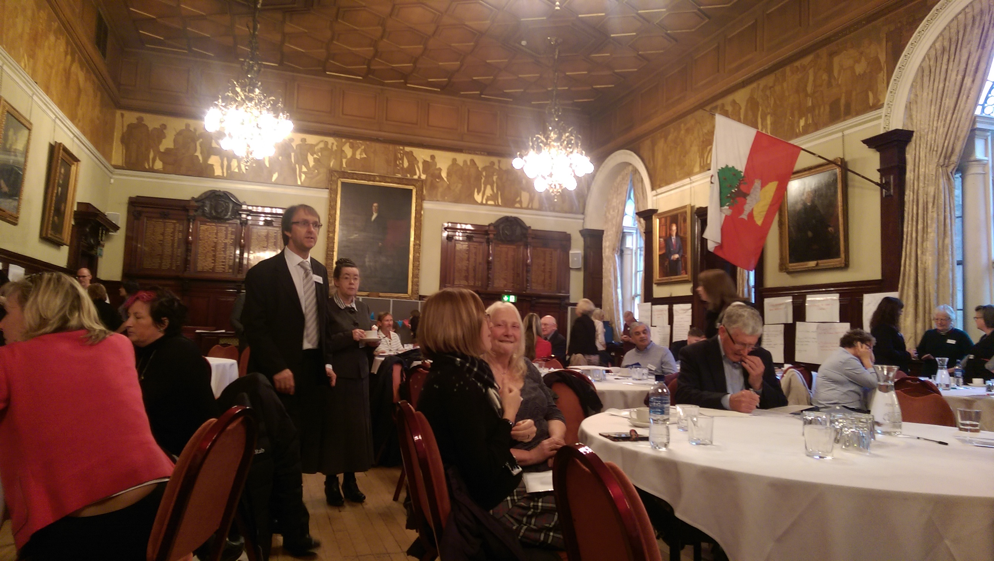

WELLBEING CHECKS
When you’re busy caring for others, it can be easy to take an eye off your own health and wellbeing. NHS Shetland is committed to helping all in our community stay as well as possible, and are inviting those we have not heard from for a while to come for a general health screening. It’s a chance to catch any niggles before they become more of a problem, talk over any

lifestyle issues and, well, just find out how you are!
You can arrange a Keep Well appointment at your local health centre or at the Health Improvement Team in Grantfield, Lerwick on 01595 80 7494. The Health Improvement Team are willing to do health checks in your own home or at your local GP surgery if that makes it easier for you.

TRAINING
We are currently reviewing the training that we can offer to carers. In the past we have provided Carers Stress Management and Moving and Assisting Training. We are still hoping to offer training for long term conditions and have also considered developing Tai Chi sessions for carers and the person you care for. Please let us know of any training you might be interested in to support you in your caring role and we will see if we can help.
MANAGING STRESS TRAINING
On Monday 18th January from 12.30 – 1.30 we will be running a course at Market House on Managing Stress. During this fun and interactive session, we will look at the causes and symptoms of stress and provide helpful strategies and easy tools that can help lift the load carers can feel when trying to meet the demands of their role.

Emergency Contact Card
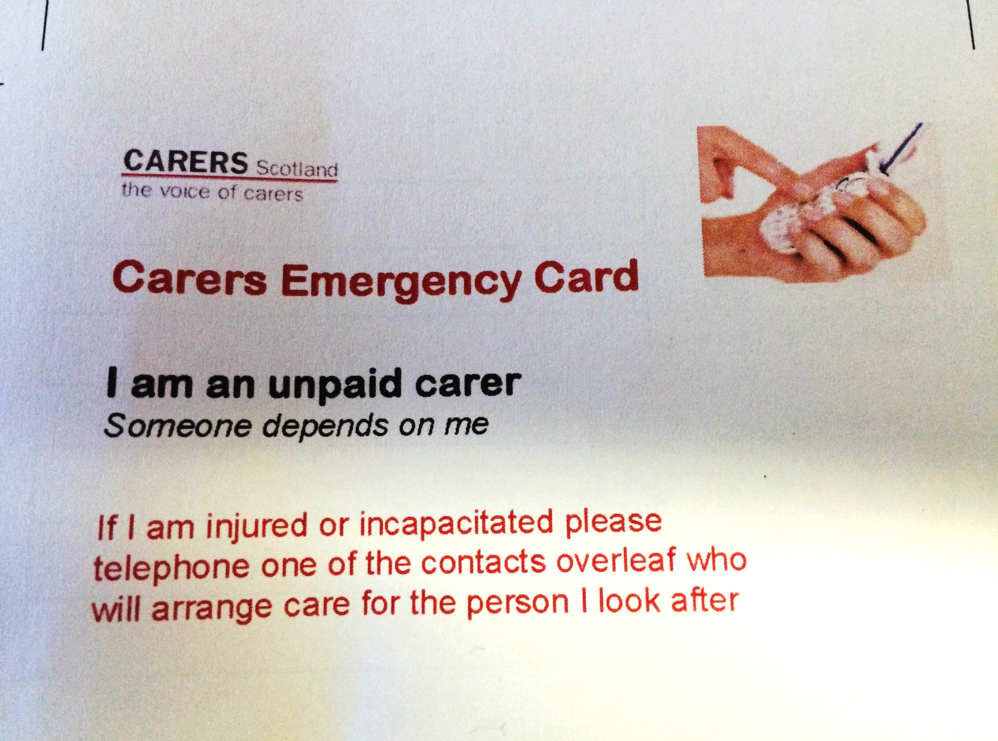

We can provide you with a laminated Emergency Contact Card for keeping in your wallet. If you would like one then please contact us and we can add your details to the back of the card before laminating.

GETTING HELP ONLINE
VAS Carers Centre staff recently attended a Train the Trainer session with Tracey Hawkins from Our Digital Zone – Shetland.

The short-term project was designed to help local people reap the benefits of being online, whether that’s for staying in touch with friends and family, improving business opportunities or booking tickets for the latest blockbuster at Mareel. So perhaps you are getting an iPad for Christmas and would benefit from a session with help on how to learn new skills and realise the benefits of being online. We are running an Introduction to the Internet Session at Market House on Friday 15th January from 10.30 – 12.30 so if you would like to brush up those skills then please feel free to pop along.

YELL AND UNST CARERS GROUP
It has been a good year for the Yell and Unst Carers group, they have continued to meet the first Wednesday of every month and taken part in various activities. In November they made Christmas decorations and this month they have been out for Christmas afternoon tea in Victoria’s Vintage Tearooms in Unst. The group will continue to meet the following dates and we usually only plan activities a couple of sessions ahead. We meet 12-2 in Yell or 11.45-1.45 in Unst:-
6th January, Yell, art / craft session 6th July, Yell
3rd February, Unst 3rd August, Unst
2nd March, Yell 7th September, Yell
6th April, Unst 5th October, Unst
4th May, Yell 2nd November, Yell
1st June, Unst 7th December, Unst

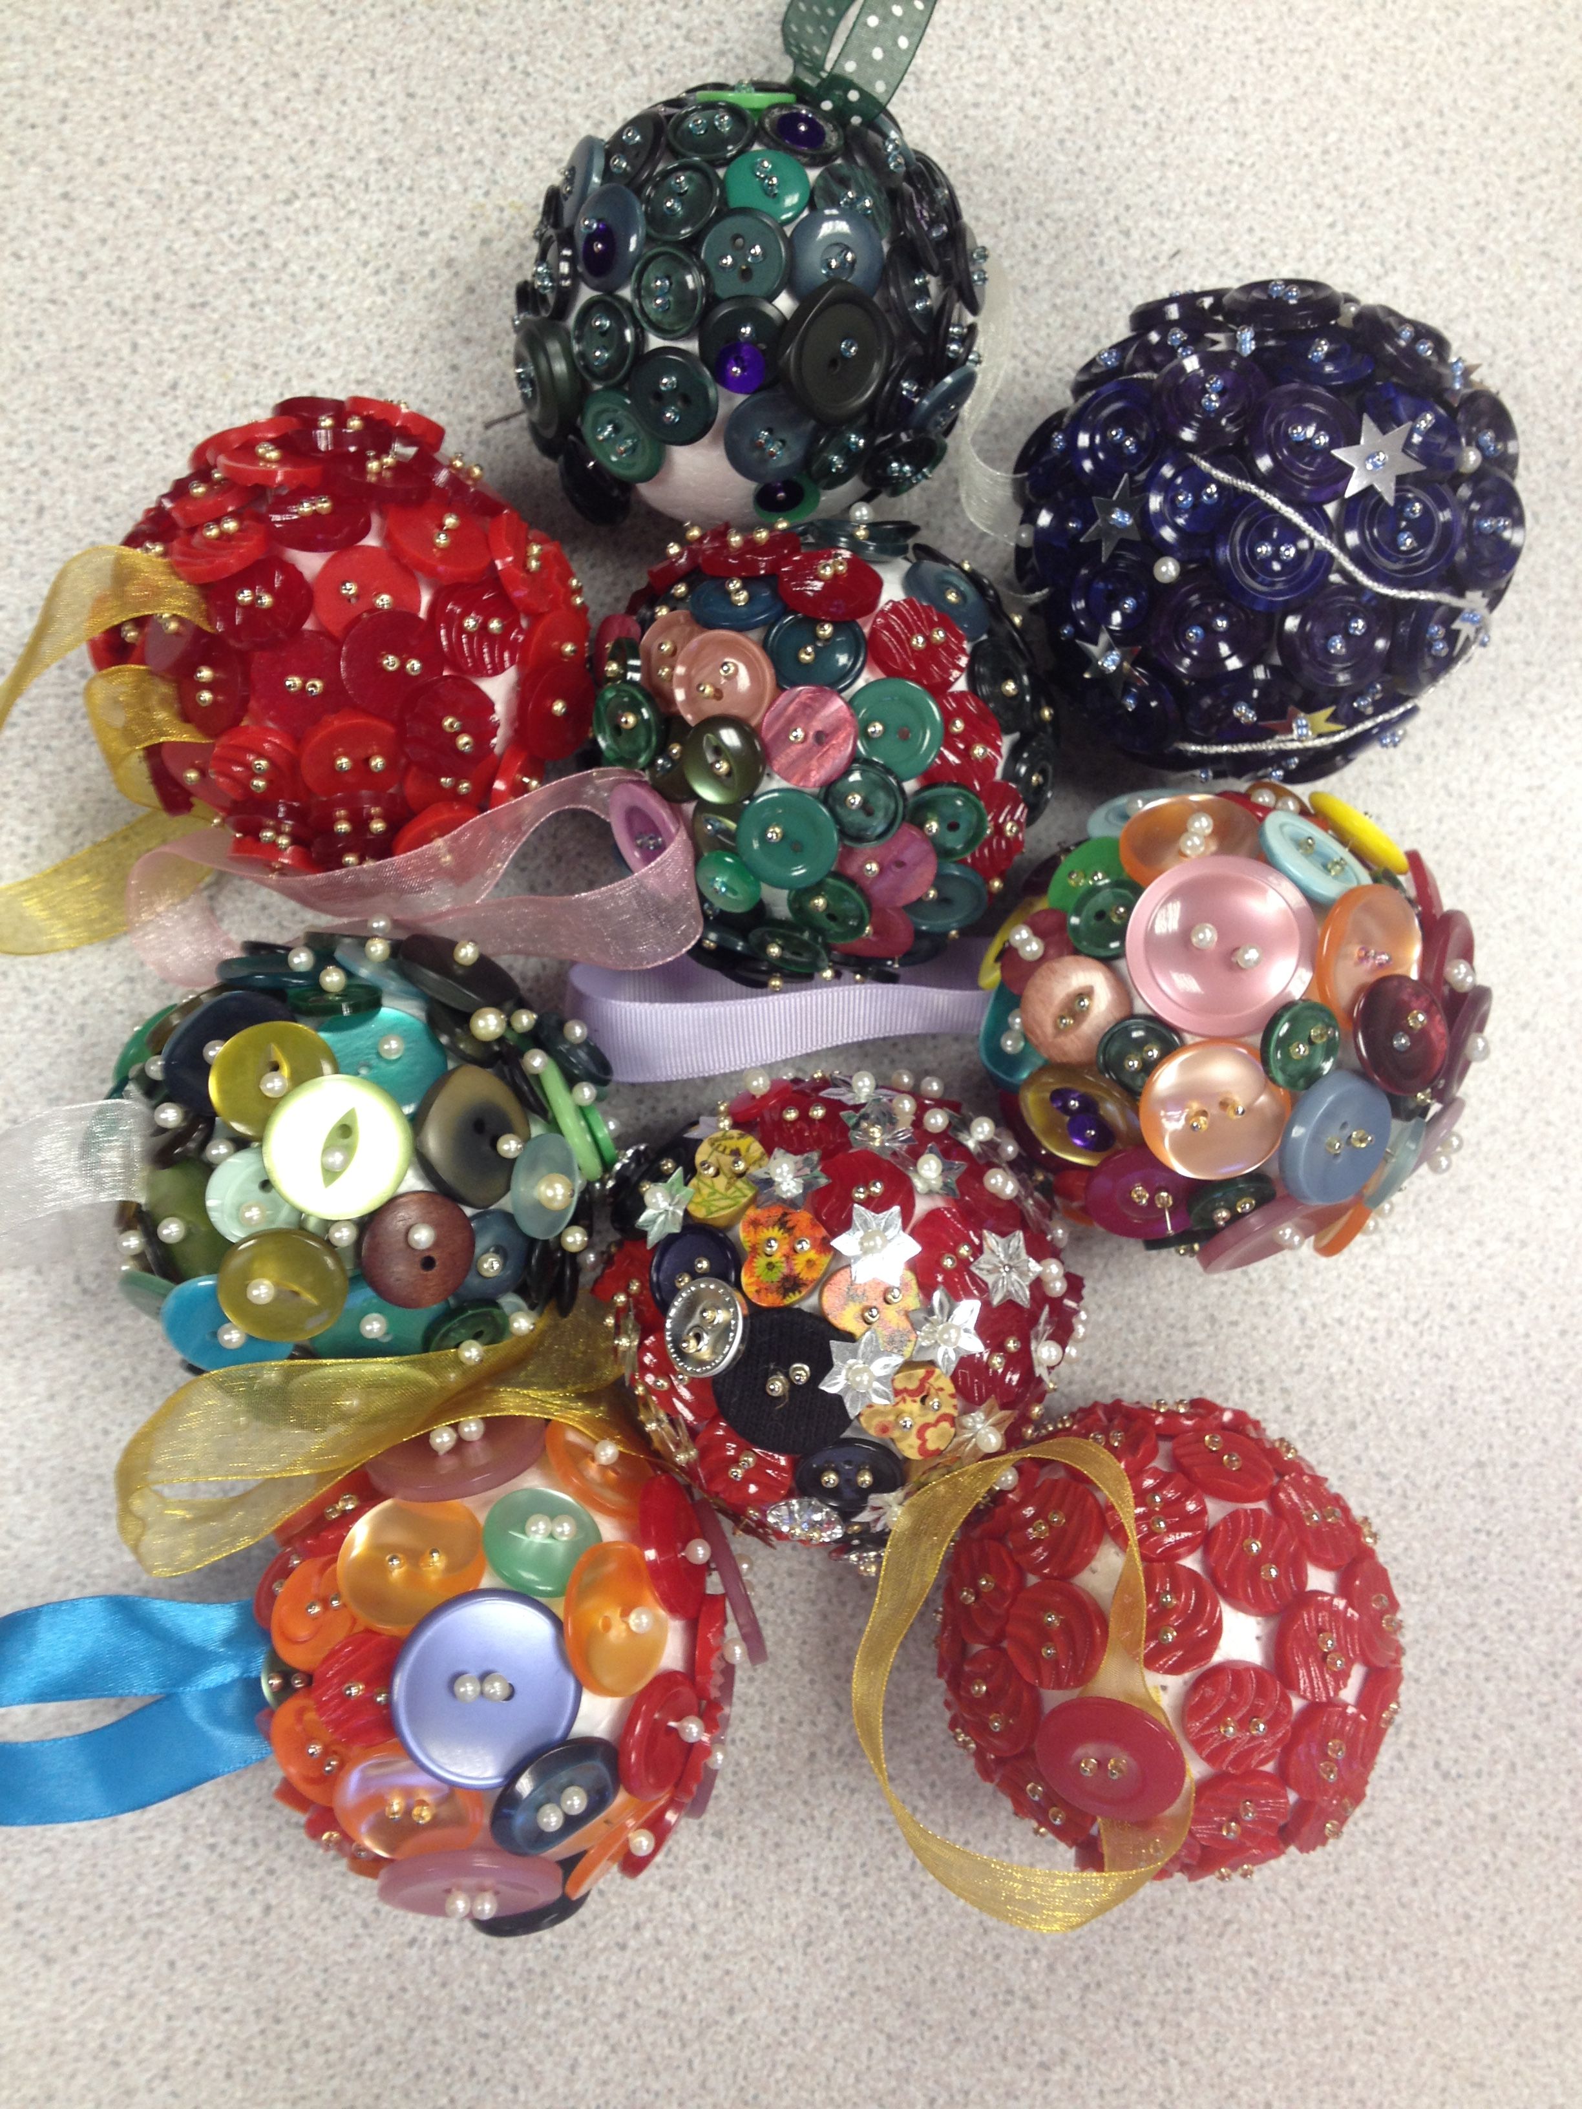
Christmas Baubles made at a recent North Isles Carers Group Session

THE STEPPING OUT TOGETHER GROUP
This group runs every two weeks on a Thursday and is for over 60’s and carers. It takes place in various halls around Yell and we try to get different activities happening and guests coming in to speak to people, but it is mainly it is a good opportunity to get out of the house and meet up with friends for a cup of tea and some soup for lunch. The sessions run from 11.30 – 2 on the dates below. If you need transport contact Karen for this to be organised, it is also useful to let us know if you are coming if you have never been before just so that we can get an idea of numbers.
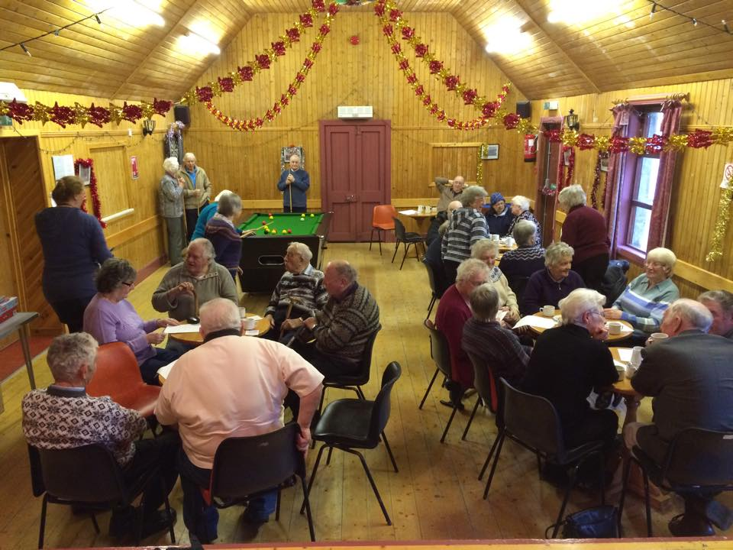
Next session dates : -
7th Jan – Sellafirth Hall
21st Jan – North Ness Hall, Citizens Advice Bureau will be up visiting that day if anyone has any questions.
4th Feb – Cullivoe
18th Feb – Westsandwick
3rd March – Mid Yell

CRAFTY CARERS 
Our Crafty Carers Group, open to any unpaid carers in Shetland, meets fortnightly in the carers centre, Market House, Lerwick to enjoy a cuppa, chat and making crafts. The group went out for Christmas Dinner to Fjara on 16th December. The group resumes after the New Year fortnightly from Wed 13th January from 10-12.

YOUNG CARERS
We are starting to be in touch with a few Young Carers and have restarted out sessions at Market House. They are held every two weeks from 4-5 pm, on a Tuesday after school. It is great for young carers to get together firstly for them to have a life outside of their caring role but it is also a place where they can safely share their experiences with others in a similar position, if they wish. I was heartened listening in to one of their conversations where one said “I didn’t know I was a carer until someone mentioned it in a meeting” and the other one said “I didn’t know either until someone suggested I come to this group.” Towards the end of the Christmas holidays we are planning to get out for a treat to the cinema and we will be starting our regular 2 weekly sessions on 19th January.



CHRISTMAS QUIZ 2015

1.‘’All is calm, all is bright ‘’ is a lyric from which festive song?
2. In the Twelve Days of Christmas how many Pipers were Piping?
3. John Callcott Horsley designed what first commercial Christmas item in 1843?
4. Who was the first British monarch to broadcast a Christmas message to the nation?
5. Who are the four ghosts in Charles Dickens' A Christmas Carol?
6. Christmas Island in the Indian Ocean is a territory of which country?
7. Can you name Santa’s eight reindeer?
8. How many gifts are given in total in the song The Twelve Days of Christmas?
9. ‘’Holy Infant so tender and mild’’ is a lyric from which festive song?
10. In which country is Lapland?



For answers please visit our Carers Centre web site at www.shetlandcarers.org/ChristmasQuiz

ELECTRONIC NEWSLETTER AVAILABLE!
If you are interested in receiving your newsletter via email, we can do that!
Contact us with your email address and we will send you a copy.
The most recent newsletter will also be available on the Virtual Carers Centre www.shetlandcarers.org

CONTACT US
Karen Hannay tel 01595 743923, email karen.hannay@shetland.org

Market House reception 01595 743 900, New carers email address : carers@shetland.org Virtual Carers Centre website www.shetlandcarers.org
Quick Response link to our Virtual Carers Centre



