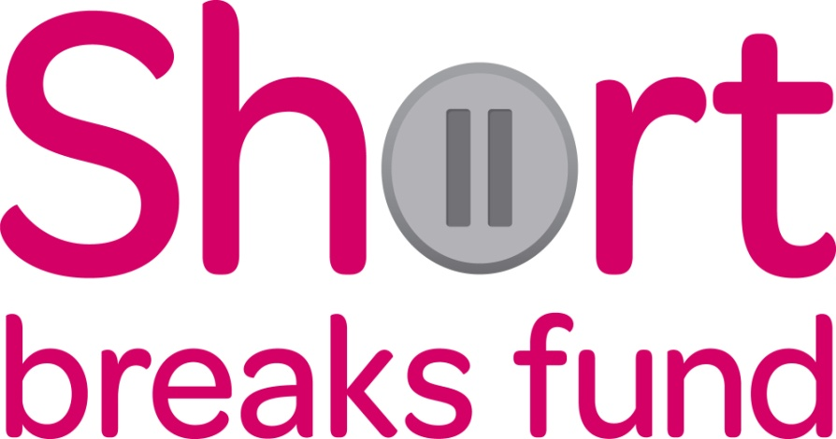
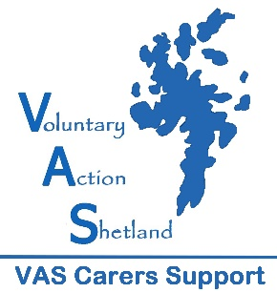
ADDITIONAL SUPPORT FOR CARERS TO TAKE A BREAK DURING THE PANDEMIC
What would help your health and wellbeing?
What would help you enjoy a life alongside caring?
Think of a new way to take a break

Applications must be received by 10th March and the break must be purchased by 31st March
What can I Apply For?
Anything that can help you to prioritise taking a break from your caring role. Despite a lot of things being closed just now there are many things that can help you have some time out. Examples are:
- Gardening equipment or furniture
- Kitchen equipment
- Counselling sessions
- Online study/classes/sports/exercise
- Tutoring or extra support for home schooling
- Gaming equipment/vouchers
- Arts/Crafts equipment/supplies
- A TV/tablet/lap top etc
- Subscription to Netflix/Prime/Disney+
- Musical instrument or equipment
- Equipment for a hobby/interest
- Subscriptions for audio books/magazines

Or something else that could help you!
VAS Carers Support Service have been allocated some additional funding from the Scottish Government to support Carers to take a break from their caring role.
This is open to all Carers, Young Carers and Young Adult Carers across Shetland. The maximum award will be £150.
Carers do not need to be registered with the Carers Centre to apply.
To apply please email: carers@shetland.org for an application form.
Priority will be given to Carers who have not applied to our Short Breaks grants before
The application cannot be for a break away or for something which does not adhere to current government guidance restrictions.

