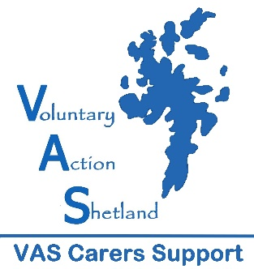

SHORT BREAKS TO STAY HOME & STAY SAFE

GUIDANCE

The Time to Live Short Breaks fund is available to benefit Carers and the people they care for living within Shetland.

During these unprecedented times of Covid 19, we understand that Carers, the people they care for and their families may need something to help them manage in these difficult circumstances. We are therefore offering small grants of up to £70. This fund will remain open for 4 weeks from 15th April or until funds are used.

Eligibility Criteria

- Applicants must be Carers, Young Adult Carers or Young Carers. A Carer is defined as someone who provides unpaid support to a family member or friend who could not manage without this help due to a long-term illness, disability, mental health or substance misuse problem.
- The Carer must live Shetland.
- Parent/guardian must sign applications for Young Carers under 16.
- If you are not known to our service, we will require the name of someone who can confirm you are a Carer

What Can be Funded?

We understand that during these times Carers cannot access a traditional type of break. This fund allows you to apply for a small one-off grant. Examples of the type of break are
- Audiobook subscription
- Magazine subscription
- Arts and crafts materials
- Online fitness membership

How to Apply

Complete the attached application form and email to: carers@shetland.org. If you have any problems, please call 01595 743980.

What happens next?

- Once you submit your application it will be considered by a panel and you will receive a response within 7 days.
- If successful, we will issue a cheque or voucher to you.
- You must provide us with receipts for your purchase/retain your receipt for auditing purposes.
- We will ask you to complete an evaluation.
APPLICATION FORM

This form should be completed by a Carer or any person supporting the Carer.

1. Information about you, the Carer

Full Name
Address
Postcode
Telephone No
Email address
Date of Birth & Age
Ethnicity (optional)
Gender (optional)
Are you registered with VAS Carers Support Service?
If no, please provide contact details for someone who can confirm your caring role

2. Information about the caring situation

What is your relationship to the person you care for.
What health issues does the cared for person have?
How long have you cared for the person?
What age is the person you care for?
Do you live with the person you care for?

3. Grant
How much would you like to apply for and what will you spend it on?
Cost:
Purpose:

Please describe how this purchase will help you and/or the person you care for
If the total grant does not cover the full cost, can you fund the rest?

4. How Are You Doing?
Please describe how you are managing during these times
Do you need help with anything else which would help your caring situation? If yes please describe what would help.

If you have not already been contacted by us during Covid 19 outbreak, would you like to be contacted?

Your signature (this can be electronic
Parent/Guardian Signature (for Carers under age 16)
Date

Please email your completed form to: carers@shetland.org
or post to Voluntary Action Shetland Carers Support, Market House,
14 Market Street, Lerwick, Shetland, ZE1 0JP (please note that postal applications may take longer to process).

